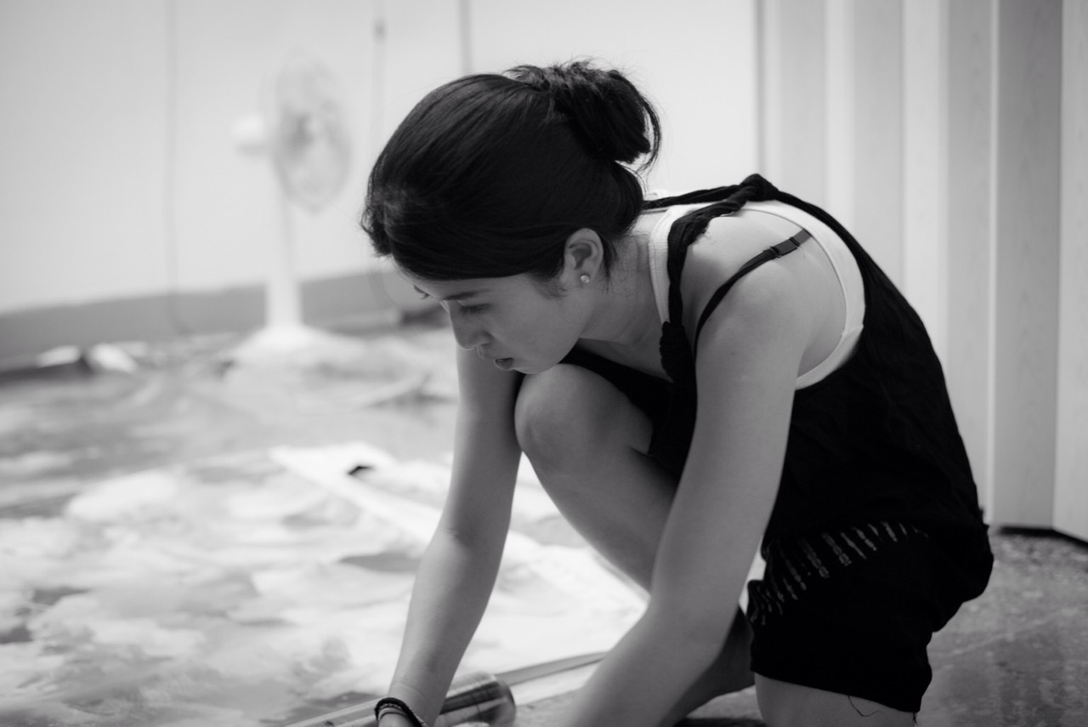**Peihang Huang**

Born in Taipei, Taiwan, 1984

**EDUCATION**

Chelsea College of Arts, MA Fine Art National Taiwan Normal University, Department of Fine Arts   MFA

**SOLO EXHIBITIONS**

2017(Up coming) Start Art Fair, Saatchi Gallery, London, Uk

2016 [UN/REAL] Grace Belgravia with Mehtabell Projects, London, UK

2015 Apocalypes, Aspace for Art collaboration, Sake no Hana, London, UK 2011 Made in Berlin:the Encounter,Tam Tam Art ,Berlin, Germany  
2009 Fleshly Fairy Tale AKI Gallery, Taipei, Taiwan

**Selected GROUP EXHIBITIONS**

2016 The Future and Potential of TAIWANESE & Japanese Contemporary Painting, Museum of Tokyo University of Arts, Tokyo, Japan

2016 Future Island-Start Art Fair Project, Saatchi Gallery, London, UK

2016 Fast Foward, Rewind -Chelsea Alumni Show,  Punctum Gallery, London, UK

2016 Affordable Art Fair Battersea, Battersea Park, London, UK

2016 Artists of the Future, Degree Arts, London, UK

2016 Up26 Auction, Polymer Studios, Taipei, Taiwan

2015 Apocalypse, A space for Art collaboration, Sake no Hana, London, UK

2015 Indescribable Figure-New Figurative Painting in Taiwan,

Jing-Lu Art, Taipei, Taiwan

2015 MA Fine Art Degree show, Chelsea College of Art, London 2015 Concrete Compendium CG11 , London  2015 compoSITE Chelsea MA Fine Art interim show, Triangle space, London 2015 Speed and Agility with Lewis PR, The House Mill,London 2014 Tangent, Chelsea MA Fine Art Mid interim show. Triangle space, London 