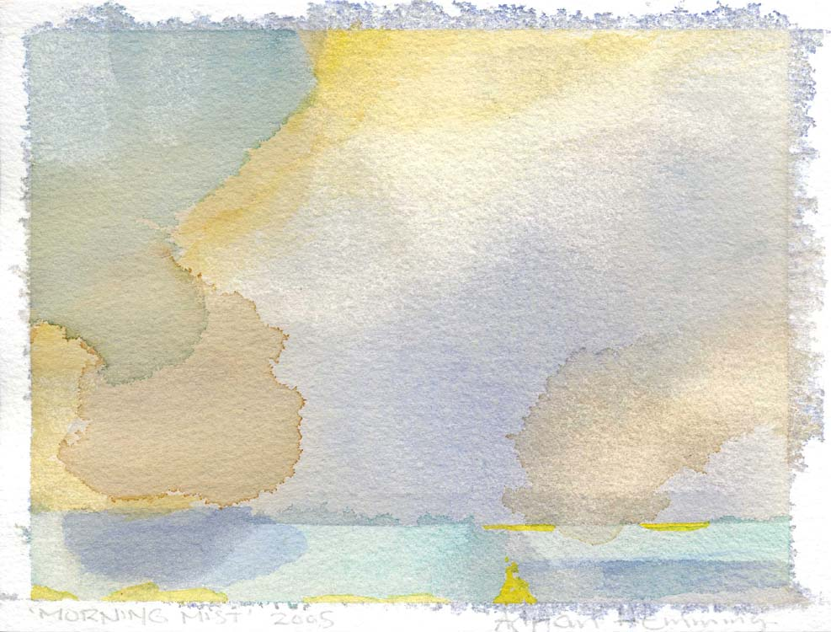
ADRIAN HEMMING SOUTHGATE STUDIOS 2/4 SOUTHGATE ROAD. LONDON. N1 3JJ
Tel. 020 7254 6485 email. adrian@adrianhemming.com web-site www.adrianhemming.com

Biography

Adrian Hemming was born in Leicester in 1945. He left school at 15 to become an apprentice engineer. After his apprenticeship he traveled widely in Europe and developed an appreciation of landscape and a love of art. On return to England, Adrian was accepted on the Foundation Course at Lincoln College of Art which he followed with a B.A. (Art) at Brighton Polytechnic (1973) and an MA (Fine Art) at Goldsmiths College, London University (1982). Adrian co-founded Tichbourne Studios in Brighton and later founded the Angel studios in London. He then went on to co-found Southgate Studios (London, N1) where he has been painting full-time since 1990.

Adrian has twice been short-listed for the Artist in Residence at the National Gallery. He has lectured and exhibited broadly in England, Scotland, America and South Africa. His work can be found in many private and public collections as well as being on public view in Terminal One, Heathrow Airport due to a major commission by BAA.

