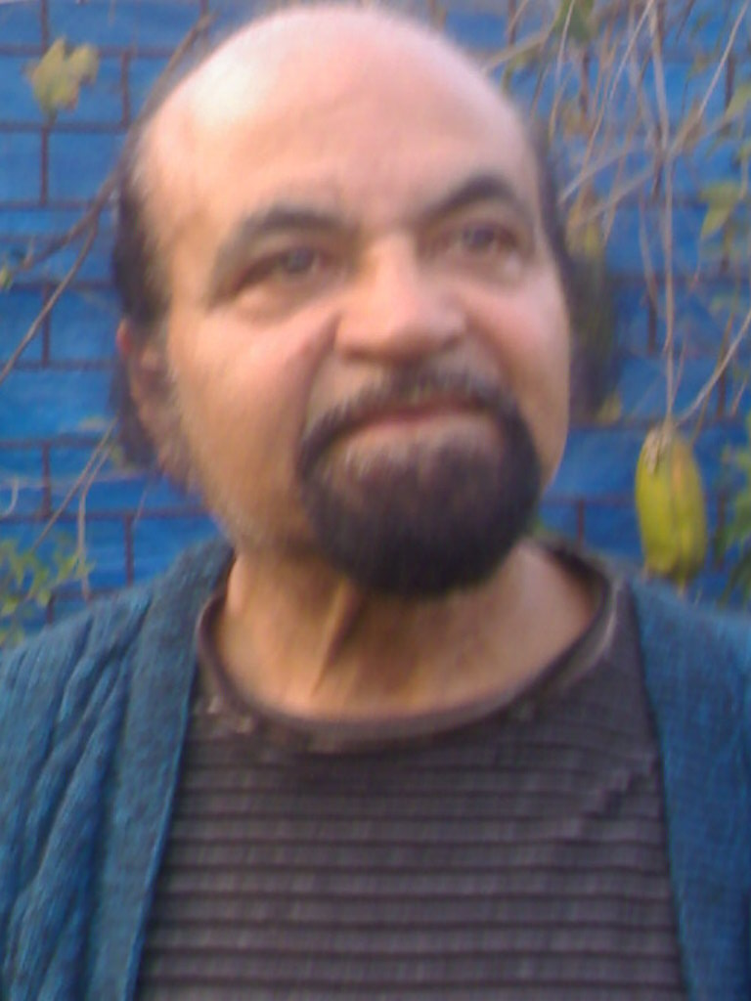

Madhusudan Kushary
mkushary_08@in.com

Born: 09-01-1943, Dhaka now in Bangladesh.

Studies
1962 Graduation in Fine Arts from the Govt. College of Arts and Crafts, Calcutta, 1964 Teachership Course in Sculpture and Commercial Art at Government College of Art and Crafts, Calcutta.

Solo Exhibitions

1963 Calcutta, 1972 Lalit Kala Academy New Delhi organized by All India Federation of the Deaf, 1984 Exhibition organized by the embassy of Panama.

Group Shows in India and Abroad
1964 Academy of Fine Art, Calcutta, 1974, 1976 All India Fine Art and Crafts Society (AIFACS) New Delhi. 1982, 1983, 84, 85, 97, 98. National Art Exhibition. 1985 Special Selected Painting, Lalit Kala Academy, New Delhi, Bangalore, Madras, Hyderabad, 1982 Kala Mela, 1983 International Art Competition at Bulgaria, 1985 Mahakoshal Kala Parishad, 1986 Participation Bharat Bhawan Biennial of contemporary.

Awards
1973 Defence Award,1981 ITDP Award, 1983 Bulgarian Award, 1985 Mahakoshal Kala Parishad award Rajpur (MP), 1986 Delhi State Award (Handycap), 1994 National Award by the President of India, 1996 Fellowship Award from Department of Culture, Govt. of India.

Collection
Late Smt. Indira Gandhi Prime Minister of India, Late Shri Rajiv Gandhi, former Prime Minister of India, Late Shri P. C. Sen, former Chief Minister of West Bengal, Lalit Kala Academy New Delhi, Kala Mela Lalit Kala Academy New Delhi. Also Private Collections in India as well as Great Britain, USA, Panama, Venezuela, Uganda, Brazil and other Countries.

Hobbies
Love to Nature, Gardening, Protect to birds and Animals.

