Renata Cebular

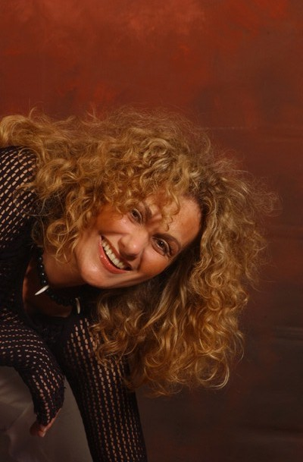

Adlikerstrasse 52
8105 Regensdorf
Switzerland

Tel. ++41 (0)44 341 48 94
Mob. ++41 (0)79 231 38 46
E-Mail r.cebular@renavita.ch
Web. www.renavita.ch

Objective: To make difference in the World of Art

Current Status: Freelance Artist
Physical Therapist (part time)
Medical Wellness Coach (part time)

Education: New Art School of Zurich/Area of Commercial Arts
School for Physical Therapy
Clasical Education High School and Elementary School
Elementary Music School « Pavao Markovac »

Art Exhibition:  „ Lebensraum“ Wellness and Support Office, Zürich, 2009/Solo Exhibition
✵ „Befire Switzerland“, Zürich,
2009/Solo Art Exhibition
✵ „Medical Office/Benedikt Loser M.D.“, Zürich,
2009/Solo Exhibition
✵ „ Tomac Computer Concept AG“, Zürich,
2008/Solo Exhibition
✵ „Bavorix AG“ Insurance broker financial planner Office, Baar,
2008/Solo Exhibition
✵ „Bar&Pizza Zürich“, Zürich,
2007/Solo Exhibition
¯ „Mode Flühmann“ Fashion Boutique, Zürich,
2006/Solo Exhibition
¯ „16. Art Exhibition–Arte10“, Zweifel Winery Zürich-Höngg,
2005/Group Exhibition

Professional Memberships and Liaisons:
- Kunstarbeitsgemeinschaft Kunst AG (Art Association Kunst AG)
- Celeste Prize

Personal: Croatian- and Swiss Citizenship

Languages: German, Croatian, English

