**Laura Matthews** *- Artist*

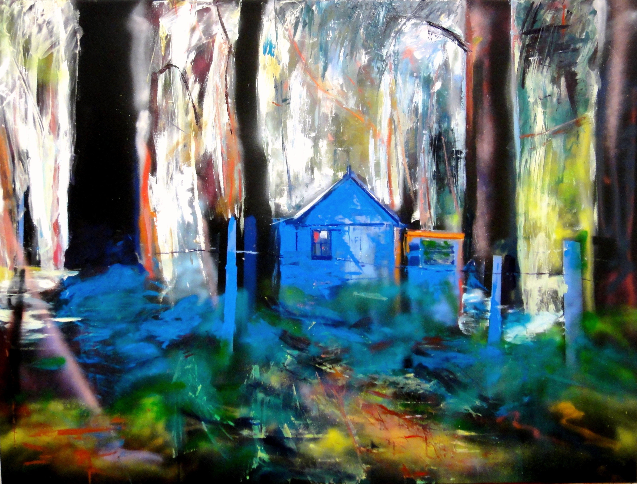

“No ^&$#@!() fairytale”

Laura Matthews is a contemporary painter/artist who had her formal education at The Slade School of Fine Art, in the United Kingdom, and who is currently living and practising in Sydney. In her studio in Balmain, Laura produces work that relies heavily on interpreting the landscape of Australia .Leaving behind memories of a paler climate, Matthews’ increasingly acute sense of colour and light has spawned large and acclaimed bodies of work since her arrival.

# Education

1987-1989: HDFA, Slade School of Fine Art, University College, London

1983-1987: BA (*Hons*) Slade School of Fine Art, University College, London

1989: Elected Freeman, Painters & Stainers Guild (London)

### Awards

2011: *Finalist* Tatersalls Art Prize

2011: *Finalist* Manning Regional Art Prize

2010: *Finalist* Paddington Art Prize

2010: *Finalist* Norvil Art Prize

2010: *Finalist* The John Glover Prize for Tasmanian Landscape

2009: *Finalist* The John Glover Prize for Tasmanian Landscape *(Highly Commended)*

2008: *Finalist Kings School Art prize*

2008: *Finalist* Portia Geach Memorial Award for Portraiture

2008: *Finalist* Kings School Parramatta Art Prize

2008*: Finalist* Norvil Art Prize, Salon

2006: *Finalist* Art On The Rocks, Sydney

2004: *Finalist* Paddington Art Prize, Sydney

2004: *Finalist* Fleurieu Peninsula Biennale for Landscape Painting

2004: *Finalist* Portia Geach Memorial Award for Portraiture

2003: *Finalist* Portia Geach Memorial Award for Portraiture

1992: The Elizabeth Greenshields Award

1990: Boise Travelling Scholarship (Italy)

1989: Elected Freeman, Painters & Stainers Guild (London)

1989: David Bailey Travelling Scholarship (France)

1987*: Finalist*, National Portrait Competition, National Portrait Gallery, London

1987: The Slade Award (Most promising figurative painter)

1987: The Elizabeth Greenshields International Award for figurative painting

1987: Cyril Sweet Award (Outstanding figurative artist)

1987: STA Award Finalist London

# Exhibitions

**Australia**

**Solo**

2011: “Nature Built it First” Despard Gallery, Hobart

2011: “Life on Mars”, Astras Galleries, Gold Coast

2010: “What Lies Beneath” Metro Gallery, Melbourne

2009: “Diemens” Metro Gallery, Melbourne

2009 “Roar” Charles Hewitt Gallery, Sydney (Televised)

2008: “Devils Heart” Art Equity, Sydney

2007: “Vistas” Art Equity, Sydney

2007: Ross Hill Winery, Presented by BCFA, Orange

2006: “Breathe” Art Equity, Sydney

2005: “Sky Sweep City Scape” Art Equity, Sydney

2004: “Caught in the Eye” Art Equity, Sydney

**Group**

2007: “Australia Day” Sydney Morning Herald Exhibition “Barbeque”

2007: “Sydney Art Fair” Group Corporate Art

2006: “Images of Little Bay” for Landcom

2005: “Affordable Art Fair” Sydney

2004: “1+2 Media” Dommayne Design Inaugural Exhibition Presented by BCFA

**United Kingdom**

2002: July move to Australia - *1+2 Artist Studios, Lilyfield, Sydney*

2001: Mixed shows, Sheen Gallery, London

2001: Mixed shows, Sheen Gallery, London

2000: Five Painters, New Grafton Gallery, London

1999: Joint exhibition; The New Grafton Gallery, London

1999: Mixed show Quantum Contemporary Art, London

1999: Mixed show, Highgate Fine Art, Highgate, London

1999-2000: Works commissioned Royal Caribbean International Cruise liners

1998-1999: Works commissioned by Royal Caribbean International Cruise liners

1998: Guest exhibitor at the New English Arts Club, Pall Mall, London

1987: Abbott & Holder, London

1997: Collyer Bristow:“A Clear Picture “

1996: Slade Summer Exhibition, “Drawing A Survey”

1996: Slade Gallery, One Woman Show

1995: New Grafton Gallery Joint show, London

1994-1996: London Contemporary Art Fair

1993-1998: New Grafton Gallery (Mixed shows), London

1992: The Heffer’s Galler, Cambridge

1991: Austen Desmond “The Prose of Painting”, London

1990: Bonhams’ “New Generation”, London

### Collections

Works contained in Slade (UCL, London) Collection

Private collections in Europe, USA, Australia and Asia

Works collected and exhibited by Royal Caribbean Cruise Liners 1998-2001

Landcom Australia

### Publications

2009: Featured Artist, Cyclomedica Calendar 2010 Edition

2009: Featured Artist, “The Apprentice” Channel 9

2007: Sydney Morning Herald, Australia Day Edition

2006: Landcom “Little Bay” Promotional material, SMH (large advertisement)

1997: Cover Piece for *The Oxford Book of Twentieth Century English Verse.* (Philip Larkin, Ed. OUP, 1997)

|  |  |
| --- | --- |
| *Teaching* 2000-02: | Lecturer in Drawing (Costume Design School of Art) |
| 1999: | Slade Affiliate Programme Tutor - Life Painting, Drawing |
| 1998-99: | Wimbledon School of Art -costume design, drawing tutor 0.5 lecturer Painting & Drawing tutor (course co-ordinator) |
| 1997-89: | Course tutor - Slade Life Drawing BA/MA students; Slade Affiliate Programme - Drawing & Life Painting lecturer |
| 1997-98: | Wimbledon School of Art Summer school |
| 1997-98: | Wimbledon School of Art Visiting lecturer (Life Drawing & studio visits) |
| 1996: | Painting & Drawing tutor Adult Ed and B-Tec Foundation Course Painting & Drawing Tutor – Richmond Adult & Community college. |
| 1994-98: | Slade Summer School continuing to work on the Alternative Foundation course, course co-ordinator for specialist drawing courses i.e., “Drawing a Way of Thinking” |
| *1990:* | *Workshops(Barbican) based around the exhibition “A Singular Vision”* |
| 1990: | Painting & Drawing course - Shell International |
| 1990: | Drawing & Painting workshops incorporating lectures on the work of Euan Uglow - Whitechapel Art Gallery |
|  |  |
|  |  |
|  |  |
|  |  |

|  |  |
| --- | --- |
|  |  |
|  |  |
|  |  |
|  |  |
|  |  |
|  |  |
|  |  |
|  |  |
|  |  |
|  |  |
|  |  |
|  |  |
|  |  |
|  |  |
|  |  |
|  |  |
|  |  |