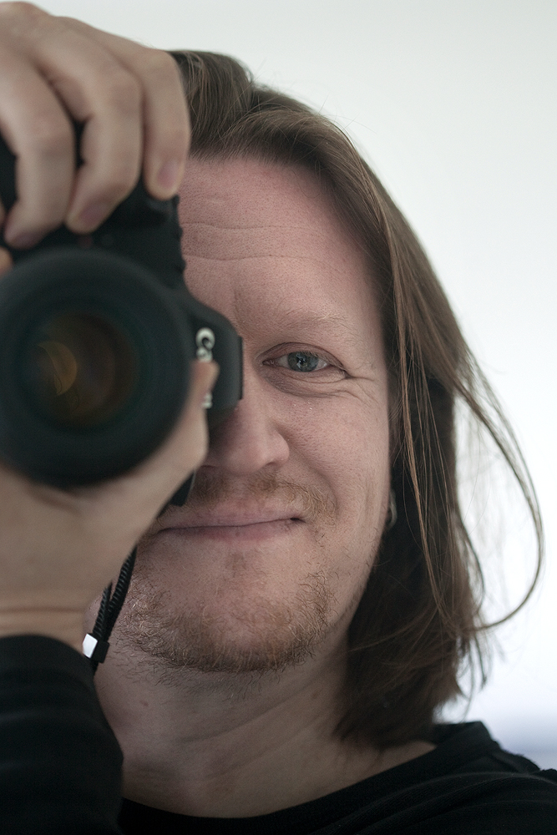
Ralf Kopp

- born 1973
- professional education as physics laboratory assistant
- 10 years in an advertising agency as graphic artist
- since 1995 art director
- since 1999 als independent videoartist
- since 2005 freelancer in the field of grafics/animation/3d/online/flash
Awards:
- hr-latelounge audience award for "think different" at ed-ward 2002
- - audience best choice award for "1 to 5 and vice versa" at fluxus 2003
Collection:

- "all ones soul" since 2005 in the collection of the
21c museum foundation louisville (louisville, ky) - bucher/kopp
- "freeJee afrika" since 2010 in the collection of minoriten galerie, graz, austriaz

Selected Exhibitions:

2010
- contemporary art ruhr (c.a.r.) 2010, weltkulturerbe zollverein, kokerei, essen, germany
- "machen wir. Teil 7: digital", galerie pack of patches, jena, germany
- galerie prento und wiesel, wiesbaden, germany
- art karlsruhe 2010 (galerie pack of patches)
- michaelskirche Darmstadt, germany
- storage show 2010 - legallery, zürich, switzerland

2009
- babels shade/im schatten babylons, pasinger farbik, munich, germany
- „intervention I: shortplay“, pack of patches, 10. jenaer kurzfilmfestival „cellu l´art X“, germany
- „machen wir. Teil 1, 2 und 4“, galerie pack of patches, jena
- the sounds of art, kopenhagen, denmark
- legallery, zürich, switzerland
- cutlog, contemporary art fair paris, france (galerie pack of patches)
- kaiser and cream, Frankfurt, germany
- „Logbuch 2009“, galerie pack of patches, jena, germany
- galerie blaues atelier, graz, austria

2008
- liquid art & design, duesseldorf, germany
- opening-exhibition“, galerie pack of patches, jena, germany

2007
- art karlsruhe (werkbund/asperger galerie)

2006
- luminale frankfurt [bucher/kopp und raumwerk architekten]
- alp galleries, Frankfurt, germany
- filmkanal VII - asperger galerie, berlin, germany
- video now, white trash contemporary, hamburg, germany
- art under the bridge (dumbo arts center), aswoon/alp galleries, new york, usa

2005
- diva, digital video art fair, new york, usa
- diva, digital video art fair, cologne, germany
- 21c museum foundation Louisville, louisville, kym usa
- evangelische kirche hessen nassau – eknh, frankfurt, germany

2004
- shanghai spring art salon, shanghai, china

2003
- ira pinto gallery, washington d.c., usa
- american Institute for contemporary german studies, washington d.c., usa

2002
- das netz - sinn und sinnlichkeit vernetzter systeme. museum für kommunikation,
frankfurt/hamburg/berlin, germany

ralf kopp
martinstrasse 81
64285 darmstadt, germany

+49 176 2710 2170
ralf@kop2.de

www.ralfkopp.com

2001
- alp galleries, new york, usa
- unity canvas, williamsburg art & historical center, new york, usa

2000
- das jahrhundert des design, karlsruhe/hannover, germany

