Sanjeet Mahalik

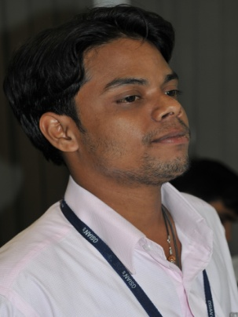
Born in Balasore, Orissa in 1985 Sanjeet Mahalik Graduated in Fine Arts at Utkal University of Culture, Orissa,

Being a versatile artist, his works are highly detailed. His use of colours is expressive and natural which defines the subject with perfection. He has a vision and variety which is distinctly done in his own unique manner and medium.

He has been awarded by State Lalit Kala, Bhubuneshwar in 2005, Avantika, New Delhi in 2006, Rai Foundation, Naintal Utrakhand in 2009, Observation of world Aids day B.B.S.R., Orissa in 2004, Gagana Bihari Memorial, Balasore, Orissa in 2006, College Annual Award in 2004 & 2006 and Osian”s award for (Up coming artist) 2009.

His private collections are in New Delhi, Mumbai, Dehrahdun, Malaysia, London, Netherlands & Switzerland, Harry H.M Lagro-Netherlands, Priya Raj William & Keolin-Geneva, Switzerland, and Mr. Neville Tuli, Osian’s Chairman-New Delhi, Ms Kiran Walia (health minister, Delhi) & Mr. Muthusamy Varadarajan (former secretary Govt of India). The Lalit hotel

He is recognized as an artist as well as Junior restorer & conservationist. He has conserved the works of following artists:in Osians & conservationist Mr.Sanjay Dhar
Raja Ravi Verma, Hemendranath Mazumdar, M.V.Dhurandhar, S.G.Thakar Singh,
A.Mullar, Jamini Roy, Abanindranath Tagore, Nandalal Bose, J.P.Ganguly,
Sajal Roy, Manjit Bawa, M.F. Husain, F.N. Souza, S.H. Raza, Gaitonde, Shanti Dave,
Sadanand Bakre, G.R.Santosh, Khemraj, Bijan Chowudhury, Bimal Das Gupta
Ramkumar, Satish Gujral, Krishen Khanna, K.G.Subramanyam, Thota Vaikuntam
Jai Ram Patel, Sohan Qadri, Ravindra Reddy, Subodh Gupta, G.R. Iranna, Robin
Mondal, Anjolie Ela Menon, Ganesh Pyne, J.Sultan Ali, L.Munuswamy, Paresh
Maity, Rameshwar Broota, Arpana Caur, J. Swaminathan, Bikash Bhattacharjee, Amrita Shergill and many of Litho prints of artists like Ravi Verma, Dhurandar and Hussain.

He has also participated in many national & international art camps. Sanjeet is presently based in New Delhi.
Working With the art value gallery New Delhi…….

