RESUME

K. SASI KUMAR 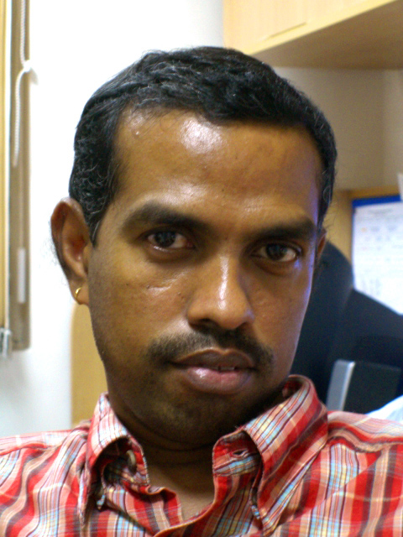
Assistant. Professor
Pearl Academy of Fashion, 82,Sterling Road,Chennai-34
RES: No. 14. 1St Main Street, Antony Nagar,
Thiruninravur, Chennai –602 024
Phone: 91- 9841470541, 044-32546825

OBJECTIVE

Hailing from an Artisan family my ultimate goal is to be a reputed Artist and Create a bench marks in the Art movement and creating a unerasable foot mark before leaving,. Also to impart my knowledge to the younger generation which I have gained and gaining in my life journey. All my work and carrier so far and from here is only focused towards this goal.

PERSONAL DETAILS

Date of Birth | 11-10-1968
Marital Status | Married
Nativity | Tamil Nadu
Languages Known | Tamil, English, Kannada, Hindi (Can Understand & Speak)
Education : | First Class in Master's Degree MFA (Ceramic), 2006  First Class in B.Sc Degree (Ceramics),1989 :  First Class in B.F.A Degree (Sculpture),2001  Government College of Arts and Crafts, University of Madras
Completed PGCHE certificate Programme, 2008
Nottingham Trent University
UK

RESEARCH TRAINING

- Research Grant from Lalit Kala Academy, New Delhi for Ceramic. Worked at Lalit Kala Academy, Regional Centre Chennai-1990

- Undergone Pottery Training Under Traditional Potters at Sevvapet, Tamil Nadu, 1989-90.

- Research Skills for Art & Design Workshop, jointly conducted by Pearl Academy of Fashion, New Delhi & Nottingham Trent University, UK

- Invited to present a paper in Textile Institute Manchester.UK for the World centenary conference.2-Nov-2010.Sponcered by Pearl Academy of Fashion, Chennai.

AWARDS

- Two Times Junior State Award for Sculpture from Tamil Nadu Ovia Nun Kalai Kuzhu, 1985 and 1998.

- Won 11 Prize for Design cum model competition in 1988 from Government College of Arts and Crafts, Chennai.

- Received Three Times Merit Scholarship awarded by Victoria Technical Institute, Chennai-1986,87,89

EXHIBITIONS

- Participated in a group show at Chitra Kala Parishad, Bangalore, 1991

- Participated in Annul State Exihibitition, Organized by Ovia Nun Kalai Kuzhu, Chennai. 1985, 1998 & 2000

- Participated in Traditional Exhibition Organized by Ovia Nun Kalai Kuzhu, Chennai. 1999

- Participated in 43rd and 44th National Exhibitions organized by Lalit Kala Academy, New Delhi, 2001

- Invited to Participate in regional Art Exhibition organization by Lalit Kala Academy, New Delhi, 2001

- Invited to participate in Homage to Dhanapal Exhibition organized by Lalit Kala Academy, New Delhi, 2001

- Participated in a group show at India Habitat Center, New Delhi, 2008, Organised by Pearl Academy of Fashion, Delhi.

- Participated in a group show at AIFACS Art Gallery, New Delhi, 2009, organized by Pearl Academy of Fashion, Delhi.

WORKSHOPS

- Participated and worked in Ceramic Camp at Pondicherry with an eminent ceramist Mr. Walter Keeler from Britain, organized by the British Deputy High Commission, Chennai

- Participated in Ceramic Camp at Lalit Kala Academy Regional Centre, Chennai

- Participated in National Sculptures Camp (Stone) organized by Lalit Kala Academy New Delhi, at Lucknow — 2001.

- Invited to participate in the l ceramic camp for the regional Art week at Kalakshetra Chennai. Organized by Lalit Kala Academy, Chennai, 2011

INDUSTRIAL / FREELANCE EXPERIENCE - 15 YEARS from 1989 to 2005

- Being a coordinator for "Kanniyappan Art Residency" promoted a well equipped residential Art studio for foreign Artists & Indian Artists to work

- Being a coordinator for a Art Material manufacturing company "SUDHA 68" have the experience in designing the machinery as well as fabricating the same and chemical knowledge in finding out new Art materials also.

- As a free lance artist, designed many murals in various medium for "Artistic" (promoters of Art & Artifacts) and for many Architects & Interior decorators

- As a free lance artist erected and been commissioned to do permanent installations and sculptures in many part of the state as well in the country.
NIFT Project & Training Program

- Interface for producing prototype packaging for Irula herbal center through NIFT, Chennai

- Conducted training program on production of packaging for Herbal Products to Irula Women SHG sponsored by DRDA, Tamil Nadu.

- Designed a life size prototype of dismantlable tent (Iron structure) for DRDA for the purpose of rural bazaar.

- Designing? Prototype development of wooden Jewelry for cluster development programme at Calicut.

- Worked as an Assistant Professor in NIFT in the F&LA department at Chennai
centre.

