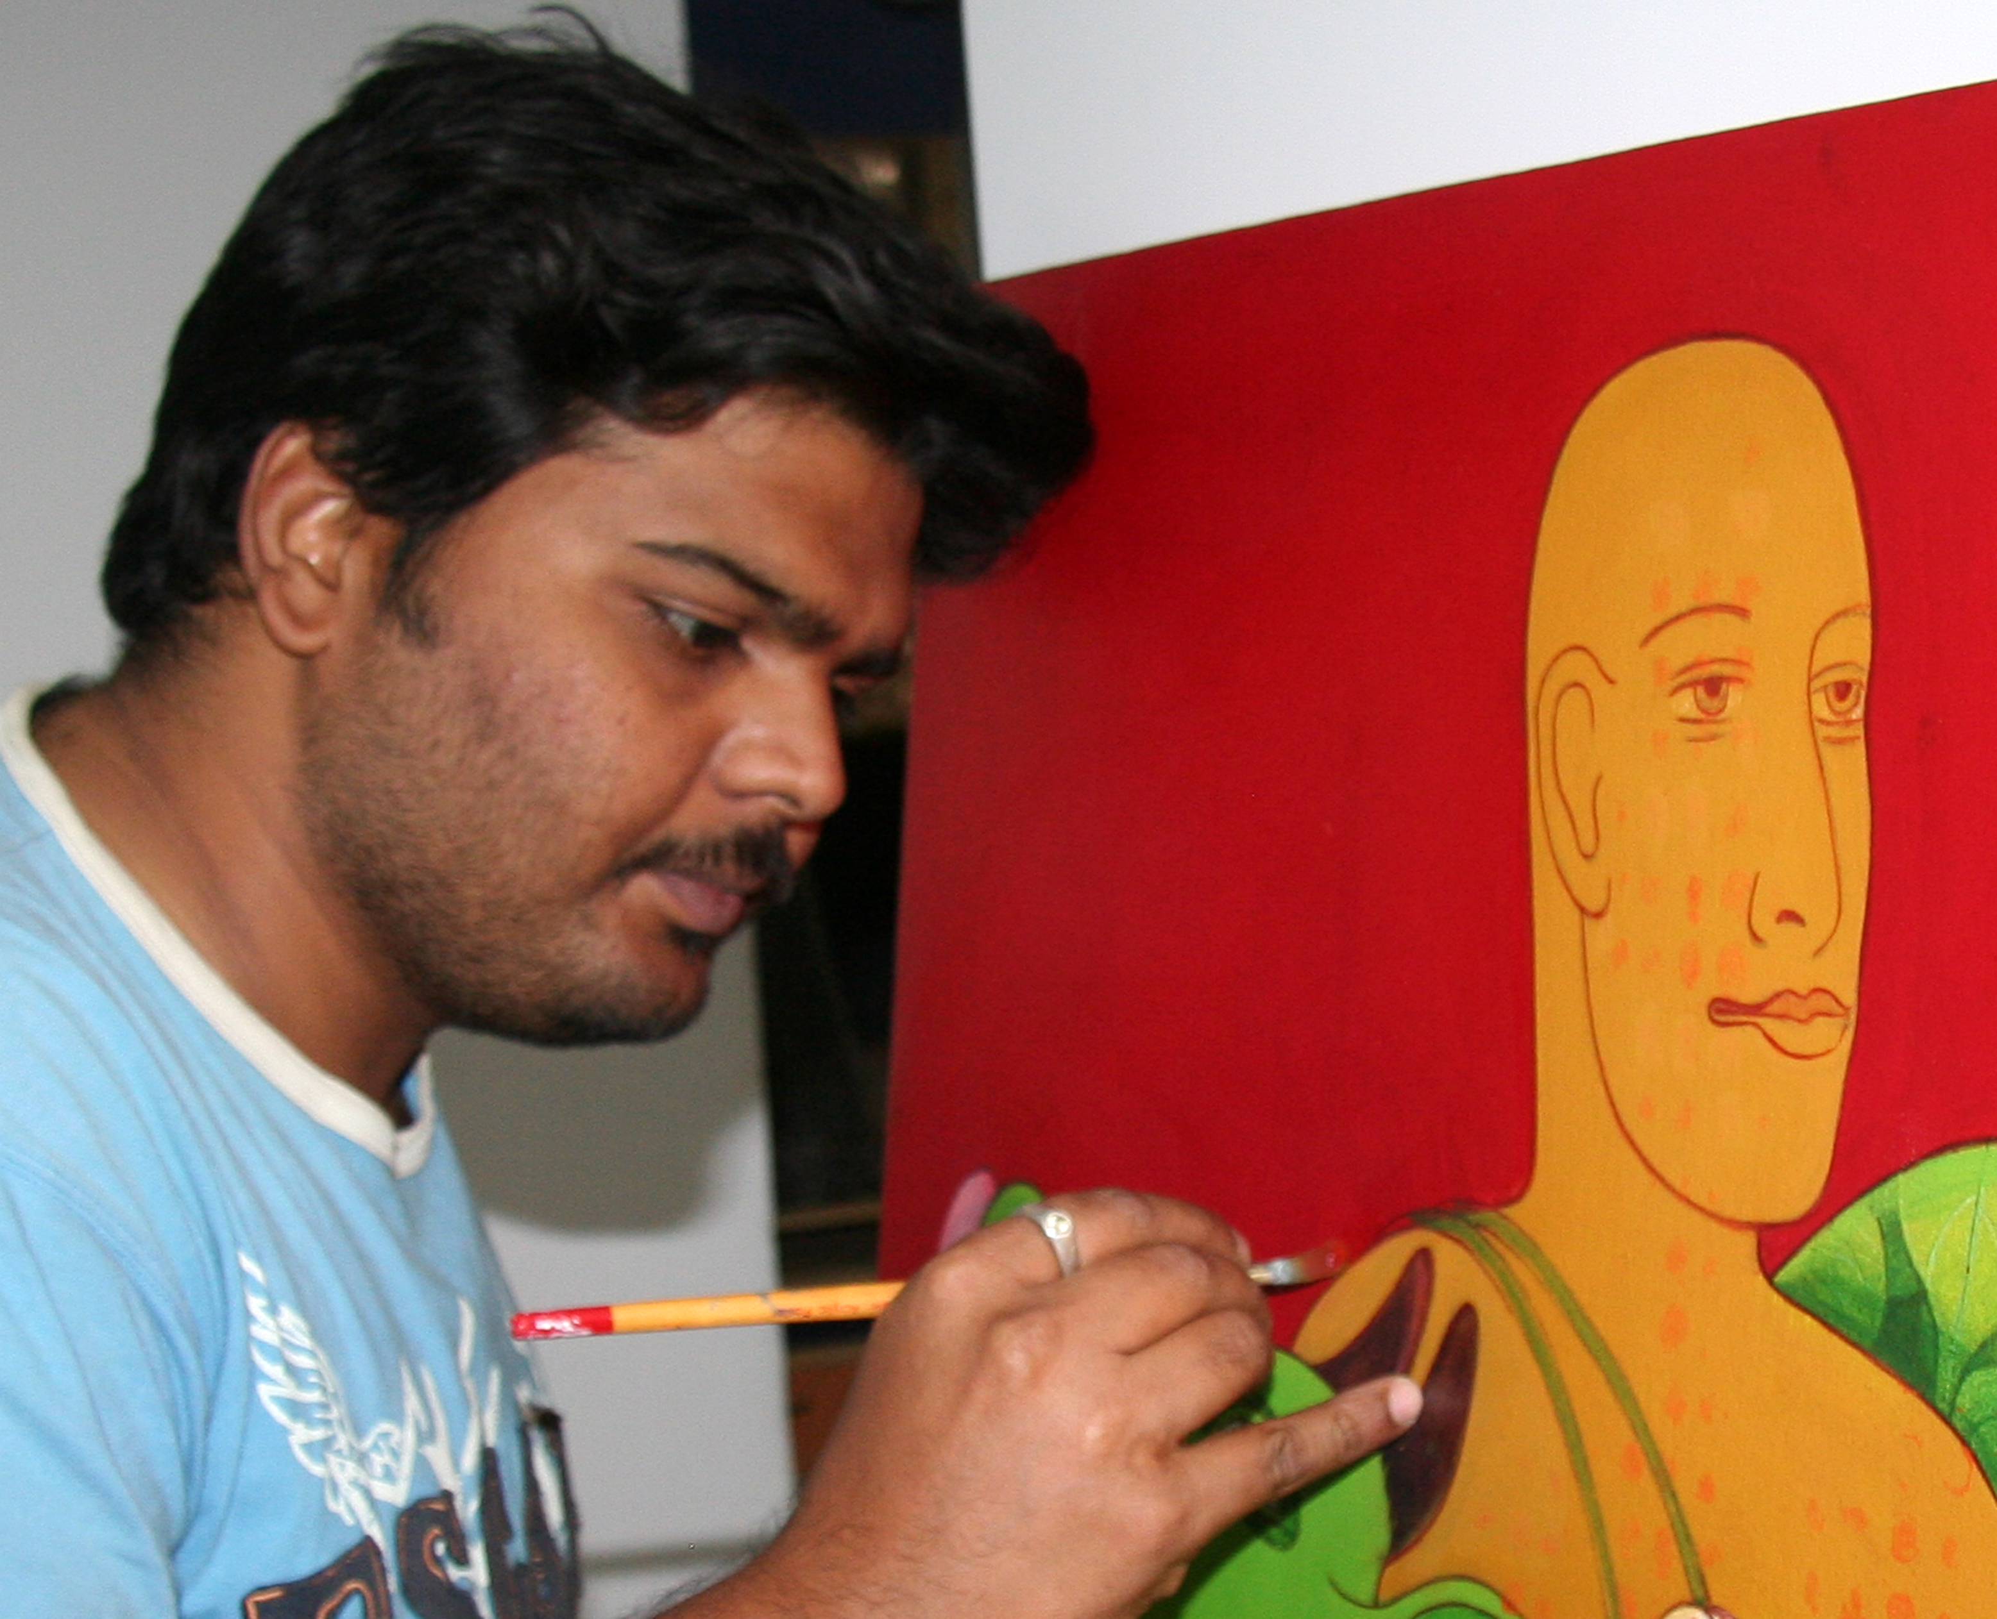
BIO DATA

SHIVKUMAR K V
(VENKATA SIVAKUMAR KAPPALA)
DOB: 25th OCTOBER 1982

ACADEMIC:
- BFA, Topped with Distinction (Major Painting / Minor Printmaking,) Potti Sriramulu Telugu University, Hyderabad, Andhra Pradesh, 2005
- Drawing Higher Grade Examinations 2001
- Drawing Technical Teachers Training Course 2001
- Studied Oil portraiture from artist Sannala, Vijayawada, Andhra Pradesh state, India. 2000
- Diploma in Cartooning, Madras 1999
PARTICIPATION / INVITED EXHIBITIONS:
- Paintscapes, Chitramayee, State Art gallery, Hyderabad 2011
- 10th, 11th, 12th Andhra Pradesh state level Art exhibition, Potti Sriramulu Telugu University, Hyderabad - 2006, 2007 and 2008
- Chitra Santhe, Art fair, Bengaluru - 28 Dec 2003
- Victoria Technical Institute, Indian Art and Craft Exhibition, Chennai-2002, 03, 04
- Hyderabad Art Society, All India Art Exhibition, Hyderabad – 2011, 2003, 2002
- 2nd All India Art Exhibition, Pullaiah Kala Nilayam, Jangaon -2002
- Simhapuri Fine arts Academy annual art exhibition, Nellore 2000 and 2001

CAMPS/ WORKSHOPS:
- Conservation of Bio Diversity, Painting Workshop, CAA & WTAA Vijayawada 15 Oct 2011
- Sculpting Forms sculpture camp, Iconart Gallery, Hyderabad, Andhra Pradesh 2011
- Aantaryami, Massive Art workshop at Guru Shri Ravi Shankar Satsang, Guntur AP 2010
- Glass Painting Workshop, ADP Software, Hyderabad 2006
- Art Camp, ADP Software, Hyderabad 2005
- SBI, National Level camp, SBI Local Head Office, Hyderabad 2005
- Painting Workshop with Mr. Indro Promit Roy, HCU, Hyderabad 2005
- Printmaking (Etching / Lithography) Workshop with Mr. Pinaki Baruva, HCU, Hyderabad 2004
- Mural camp with Prabhakar Kolthe at IIT, Powai, Mumbai 2002
- Painting Camp, Folklore Museum, Telugu University, Warangal 2002
- Book Illustration Workshop, Literacy House, Andhra Mahila Sabha, Hyderabad 2001
- UNICEF Hyderabad, Mural painting at IGM Stadium, Vijayawada 1997
GROUP SHOWS:
- JIVA, International Bio Diversity Conference, State Art Gallery, Hyderabad 01 OCT 2012
- Life Together, Bio Diversity Concepts, Iconart Gallery, Hyderabad 28 SEP 2012
- UN[TITLED] Online Indian Art Exhibition at Art Flute, Bengaluru, Hyderabad 2011
- In The Face, Iconart Gallery, Hyderabad, 2011
- Look Again, Hasta Gallery Hyderabad 2007
- Four man show, Chitramayee, State Art gallery, Hyderabad 2007
- Art for Tsunami, ITC Sheraton Grand Kakatiya Hotel, Hyderabad 2005

SOLO EXHIBITIONS:
- Configured Iconart Gallery, Hyderabad- 2010
- TRANSFORM Chitramayee, State Art gallery, Hyderabad- 2007
- Railway Junior College, Vijayawada, Andhra Pradesh state- 2000
AWARDS:
Gold Medal, 2nd All India Art Exhibition, Pullaiah Kala Nilayam, Jangaon, Warangal -2002
Winner / Runner ‘Spot Painting’ State level Inter Universities-collegiate meet- Srujanotyav, Vijayawada- 6 Jan 2000 / 25 Jan 2001
Numerous Awards on Spot the Painting and Art Competitions / Exhibitions at National Level

PEDAGOGIC:
DIPLOMA (Successful Art Teacher,) Young Envoys Internationals’ 4th International Youth and Child Art Exhibition- Hyderabad 2012
Uttam Acharya Puraskar, All India Youth and Child Art Exhibition Vishwakala Darshni, Rajahmundry- 2011
Enacted as Judge for various art Competitions

COLLECTION:
Padmashri Jagdish Mittal
Dr. Reddy Labs
Mr. T. Vaikuntam
A D P Software- Hyderabad
State Bank of India (HYD Local Head Office)
Mane’a Salons AP
And other private

PRESENT and PERMANENT ADDRESS:
S /O K. Guravaiah (Late)
# 19-13-18/1, Rajarajeswaripet
Nizam Gate, Vijayawada
Andhra Pradesh, India- 520 001

Mobile : + 91 9642214117, +91 7893716717
E-mail : shivkumarkv@gmail.com
Web : shivkumarkvart.wenode.com
Blogsite : shivkumar0000.blogspot.com
Married to : Sailaja K

Presently practicing Art and working as an Art and Clay Modelling Teacher.

I hereby declare, all the above mentioned details from exhibition records, awards, and activities are genuine.

Station :
Date : (SIVAKUMAR KAPPALA VENKATA)

