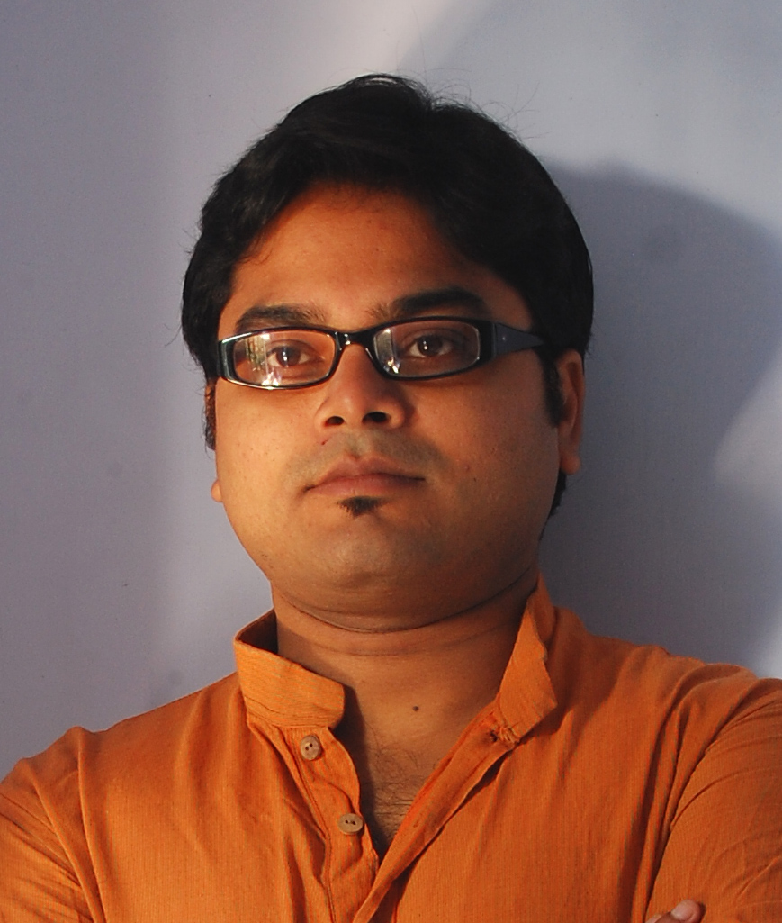 Curriculum vitae

Biswajit Das
Manila Estate, Flat No-B4, 288/A. Col. K.P. Gupta Road, Halisahar, P.O.-Nabanagar, Dist-24 parganas (N), WestBengal-743136, India. Ph. no.09007382903, Email-- biswajit.das777@gmail.com
Date of Birth: 17th January 1982
Nationality: Indian
Language Known: French, English, Hindi, & Bengali
Education: Bachelor of Visual Art from Government College of Art & Craft,
‘University of Calcutta’, West Bengal, India, 2006.
Achievments:
Exhibition: VIBGYOR, group show, JS art Gallery, Mumbai, 2016
3rd Annual show, Emami chisel art Gallery, Kolkata,2016
16th Online Artavita Contest, artavita.com, Santa Barbara,
CA, USA, 2015
Kalanand emerging artist award, Prafulla Dahanukar art
Foundation, Mumbai, 2015
2nd Annual show , Emami chisel art Gallery, Kolkata, 2015
Group show, Nehru Centre, Mumbai. India, 2014
Group show, Academy of fine arts, Kolkata, 2014, 2015
8th annual show of contemporary group of modern art,
Gallery Gold, Kolkata, 2013
Nostalgia 13, Birla academy of art & culture, Kolkata, 2013.
7th annual show of contemporary group of modern art,
Birla academy of art and culture, Kolkata, 2013.
”Trends”-Triveni Kala Sangam, New Delhi, 2009.
Annual show,Birla academy of art and culture, Kolkata, 2007, 2014.
Goden Brush 2007.
Charukala Utsav 2005, 2006, 2007, 2014, 2015.
College Annual 2002-2006
Workshop: Howrah centenary celebration, 2005
Collection: Private collection in India, Canada, France.
Gallery collection: Chateau des reaux, France.
Krishna Art Collection, indian art ideas, New Delhi, India.
Mon art gallery, Birla academy of art and culture, Kolkata, India
Awards: Basanta Ganguly award from Government College of Art & Craft, 2006
Suhash Roy award from Prafulla Dahanukar Art Foundation.2015
Certificate of excellence, artavita.com, 2015

