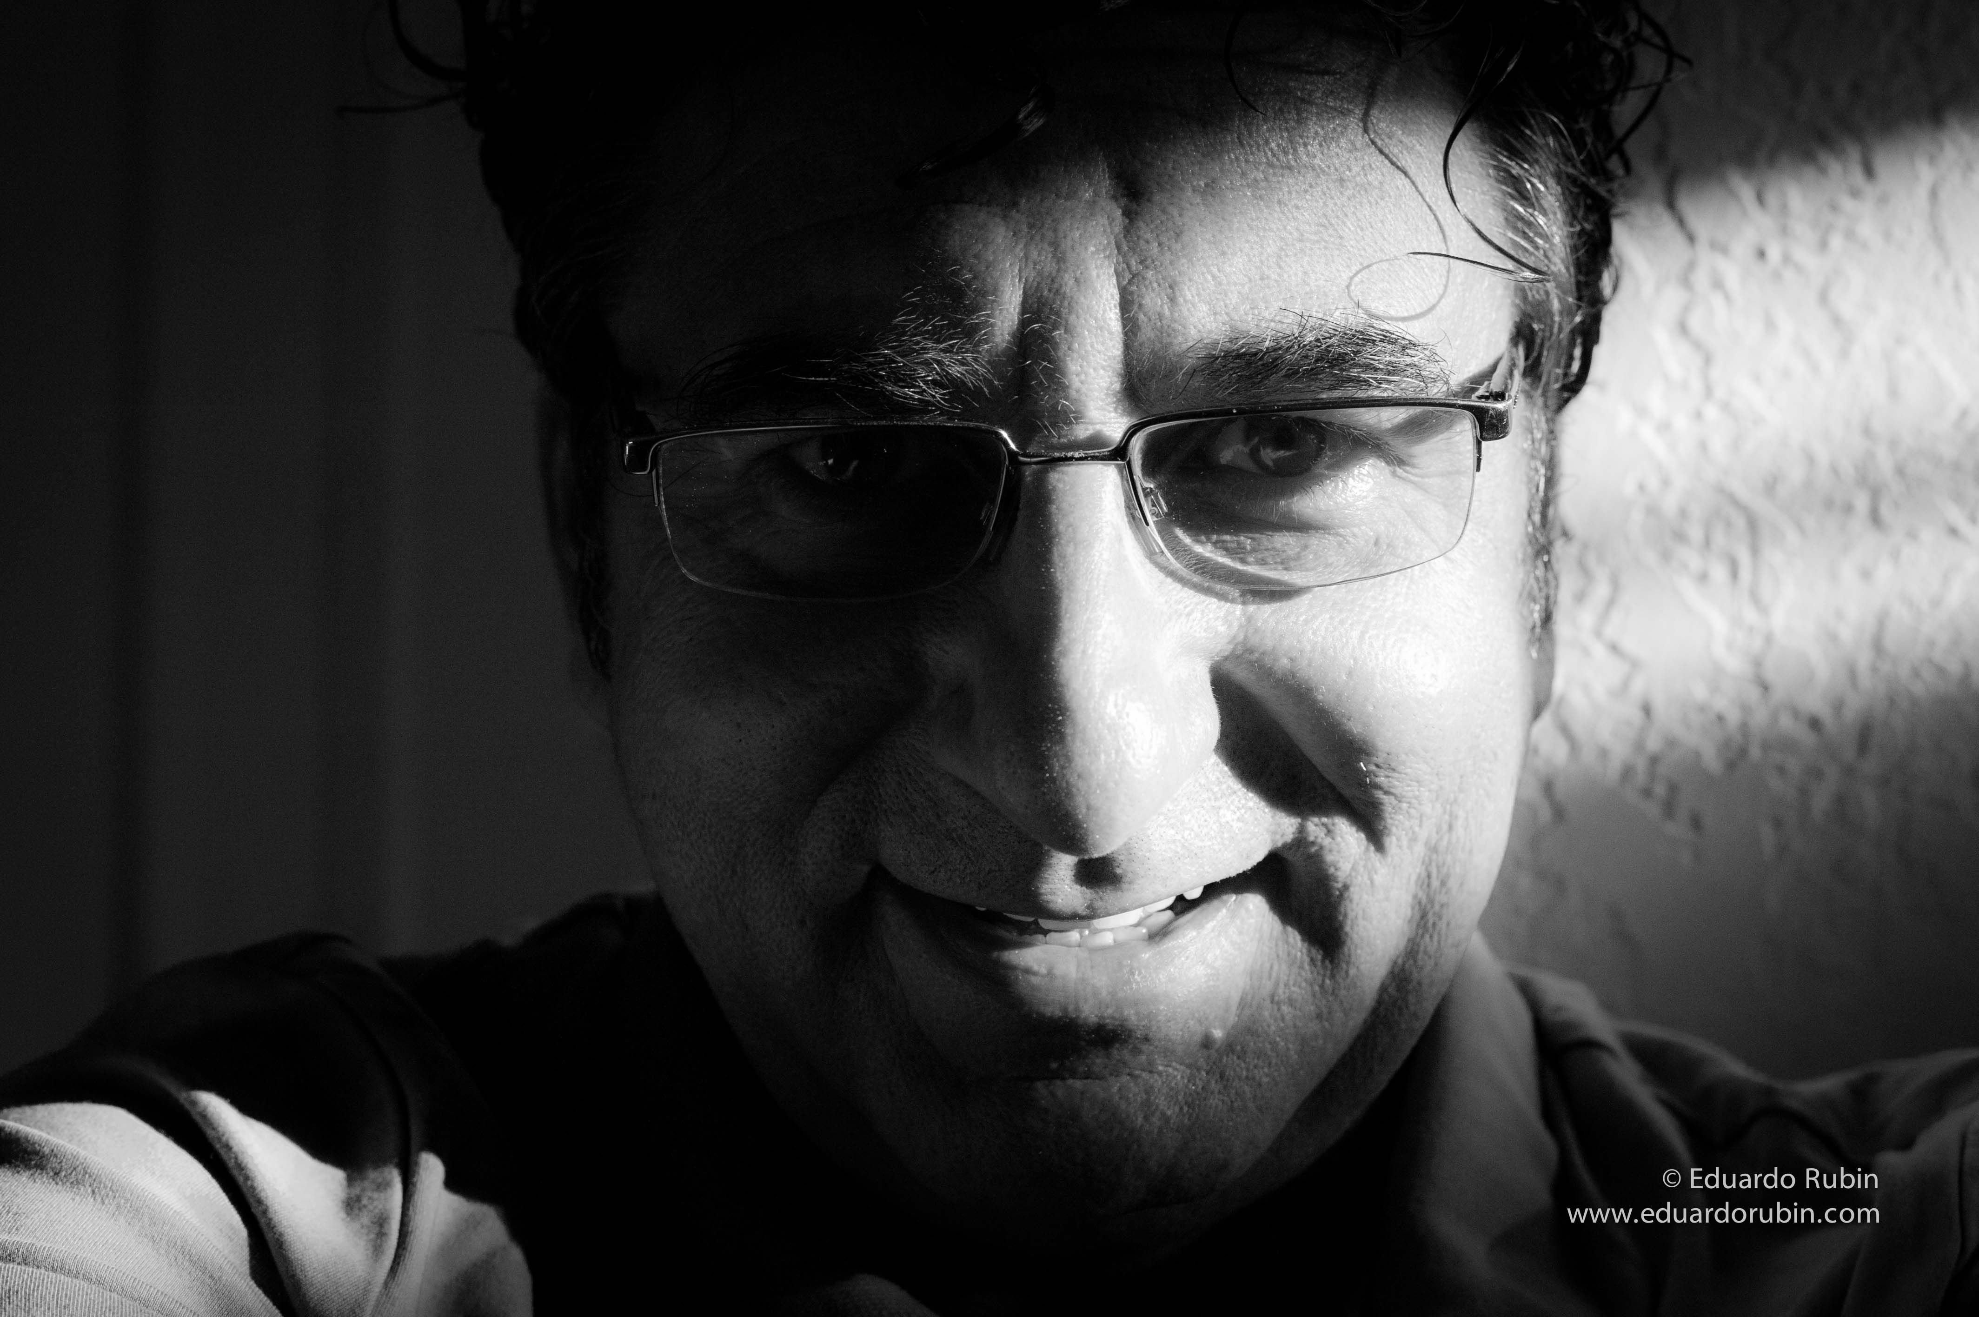

Biography – Eduardo Rubin
Photographer – Creative Director
eduardorubin.com/photo-blog/
eduardrorubin.com
facebook.com/TheCityVoyeur

Eduardo Rubin has more than 20 years of experience in Marketing & Advertising, designing and implementing all aspects of the marketing process for large, mid-sized, small and start-ups companies in US and Latin America such as: American Express, Citibank, HSBC, Jany King, Deutsche Bank, Fort Lauderdale Duty Free Shop, MasterCard, Visa, IDT, Agip among others. He is an accomplished Creative Director with meaningful experience in group-facilitation principally focused on decision-making and creative processes.
He begin his career in Citibank Argentina in the Training & Development Unit, and then moved to Marketing, bringing his experience from the creative process in teams to the communication to clients and then to his own Marketing & Advertising Companies.
In 2002 Eduardo moved with his family to South Florida, USA, and soon after he started to find in the photographic composition a new professional stage, looking for precise moments to capture ideas and feelings with a peculiar artistic expression.
He published in 2011 the first book of his series “The City Voyeur – Barcelona”, published by Sol90, a project that led him to Northern Africa, Europe and Eastern Asia.
He has exhibited his artwork in Agora Art Gallery in New York and Red Dot Art Fair Miami, during Art Basel. His Profile and Artwork has been published in “Art is Spectrum” and “Art Tour International”.
Eduardo is a Social Psychologist, born in Argentina. He is married and has two sons.

