Hacene Rahmani cite fougeroux bt10E N°16 Bouzareah Algiers 16011 Algeria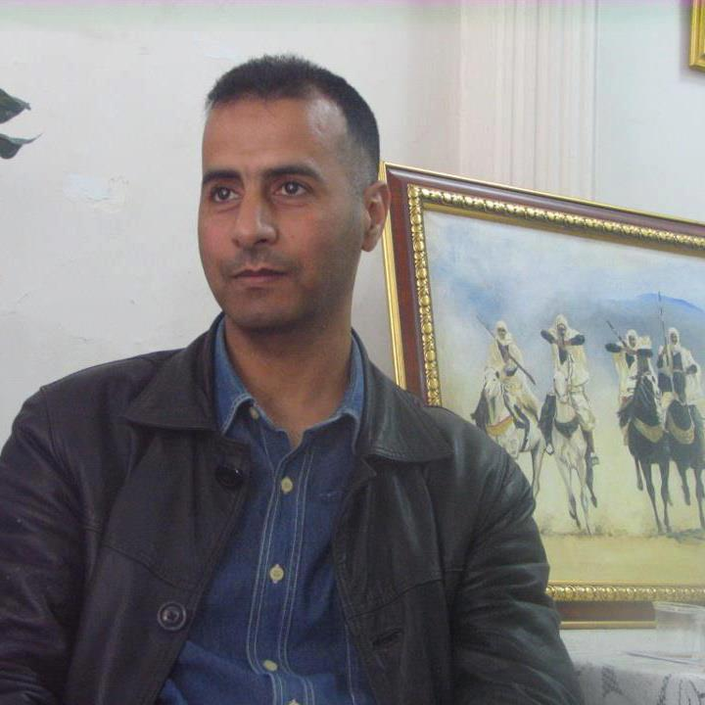

Phone Number :+213550148175
Email:ritouuk@yahoo.co.uk
Personnal details
Artiste painter poet writer (in arabic french and english)
Artistic acomplishement
Poet publisher in england
International librairy of poetry
finalist in a contest of an American poet society with the poem (Shy only with you).
Some local exibitions
Web.
http://www.onefineart.com/en/artists/rahmouni/index.shtml

www.absolutearts.com/portfolios/v/vitorio/
Employment Experience

1995/1997 .versatile worker
1997 /2005 . waiter in one cofee restaurant
2007/2014 . computer teacher in college
. Education Assistant
AsLeader.with ( EF International Language) to BRISTOL. OXFORD. LONDON
Language

Arabic . Spoken and written
English . Sspoken and written
Frenh . Spoken and written
Spanish . School notions.
Software Familairity

Software Windows , Word Exel , internet

Languages

French Spoken and written.
English First language.
Spanish School notions.

Hobbies

Sports, football, running tennis skiing , Music
Others interests, art literature , Museum Theatre exibitions writing .painting

