**BILL SORTINO**

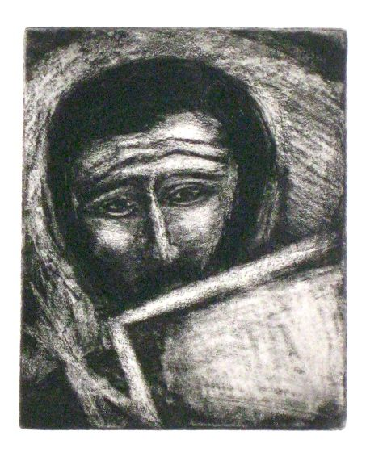

EDUCATION

BS, Quinnipiac University, Connecticut

Southern Connecticut College

Studied with Alex Zarik, Connecticut

**Selected Exhibitions**

**SOLO EXHIBITIONS**

2014 Wheelhouse Art, Santa Fe, NM

2000 Alpha Group, Santa Fe, NM

Art Struktura Int'l., Albuquerque, NM

1995 Cyndie Maiss Gallery, Reno, NA

1994 Amos Joseph Gallery, Santa Fe, NM

1993 Atherton Gallery, Santa Fe, NM

1992 Atherton Gallery, Santa Fe, NM

1991 Turner-Carroll Gallery, Santa Fe, NM

1990 Waxlander Gallery, Santa Fe, NM

1989  Waxlander Gallery, Santa Fe, NM

Riggins Gallery, Scottsdale, AZ

Dewey Galleries, Santa Fe, NM

1988 Eastside Gallery, Santa Fe, NM

1984 Durango Arts Center, Durango, COL

1983 Concepts Gallery, Santa Fe, NM

**GROUP EXHIBITIONS**

2014 Wheelhouse Art, Santa Fe, NM

2013 Highlands University Museum of Fine Art, Las Vegas, NM

2001 Helix Gallery, Santa Fe, NM

1998 Palance/Wilding Fine Art, Santa Fe, NM

1997 Palance/Wilding Fine Art, Santa Fe, NM

Art Struktura Int'l., Albuquerque, NM

Atelier Monika Schliephack, Frankfort, GER

Jay Barros Assoc., Richmond, VA

Cydnie Maiss Gallery, Reno, NA

University of New Mexico, Albuquerque, NM

1995 Arte Struktura Int'l., Albuquerque, NM

1994 Amos Joseph Fine Art, Santa Fe, NM

Sharon Parks Gallery, Menlo Park, CA

Tercera Gallery, Los Gatos, CA

1992 Atherton Gallery, Santa Fe, NM

1991 Turner-Carroll, Santa Fe, NM

The Collection, Seattle, WA

Riggins Gallery, Scottsdale, AZ

1989 Waxlander Gallery, Santa Fe, NM

Dewey Galleries, Santa Fe, NM

1988 Eastside Gallery, Santa Fe, NM

1986 Edith Lambert Gallery, Santa Fe, NM

Bluxome Gallery, San Francisco, CA

Hunsacker-Schlessinger Gallery, Los Angeles, CA

1983 Smith-Stewart Gallery, Santa Fe, NM

Concepts Gallery, Santa Fe, NM

1982 Downtown Gallery, CT

Laura Klein Gallery, CT

**JURIED AND INVITATIONAL EXHIBITIONS**

2014 The Armory Show Invitational, CCA, Santa Fe, NM

2013 Highland University, Las Vegas, NM

2003 100 Santa Fe Etchers, Argos Gallery, Santa Fe, NM

2000 Organic Forms, Earthly Elements, Helix Gallery, Santa Fe, NM

1998 Sculpture In Wood, Palance Wilding Gallery, Santa Fe, NM

1996 Variety of Museums in Spain-Constructivist Works

1995 New Mexico Tech, Socorro, NM

1994 Santa Fe Printmakers-Past and Present, Santa Fe, NM

1992 "Close to the Border", New Mexico State Univ, Las Cruces, NM

1992 "Modern Modonna", Edith Lambert Gallery, Santa Fe, NM

1992 Shrine Show, Owings Gallery, Santa Fe, NM

1988 Deco at Deweys, Dewey Galleries, Santa Fe, NM

**HONORS AND AWARDS**

1997 Fellow, Virginia Center for Creative Arts, Sweet Briar, VA

1995 Fellow, Virginia Center for Creative Arts, Sweet Briar, VA

1992 Fellow, Virginia Center for Creative Arts, Sweet Briar, VA

1990 Fellow, Virginia Center for Creative Arts, Sweet Briar, VA

**MUSEUMS**

The Museum of Fine Arts, Santa Fe, NM

Highlands University Art Gallery, Las Vegas, NM

**PUBLICATIONS**

100 Santa Fe Etchers, Robert Bell, Santa Fe, NM

[Amazon.com](http://amazon.com/)