Cecilia Hurtado
Mexico City, 1973
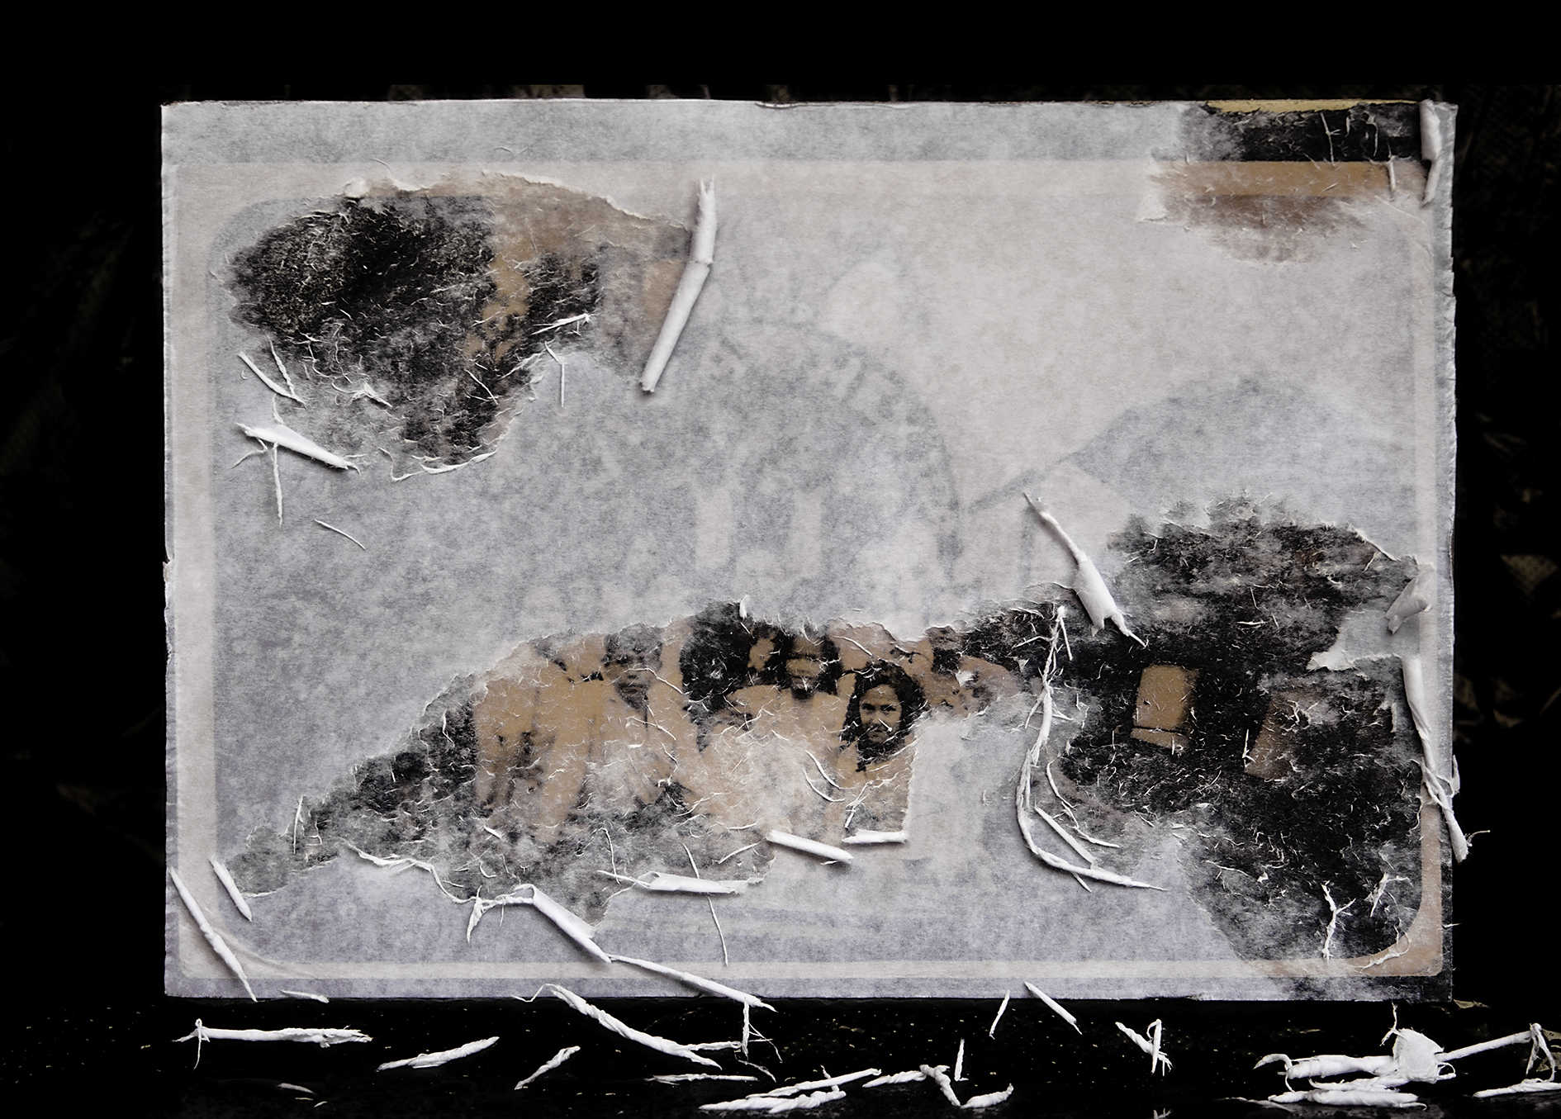

Nápoles 42-7
Col. Juárez
C.P. 06600
Mexico City
Tel. +52.55.520.73.570
Cel.+52.55.47.88.10.94

http//:cecilia-coleccionstadesecretos.blogspot.com
cecilhurtado@gmail.com

Whether based on a collection of intervened anonymous photographs, images that document the photographic process, constituting works of art in and of themselves, or a reflection on extinction and memory, the common denominator of Hurtado’s photographic language is a constant effort to tie the image in with a desire to comprehend time, loss and absence, identity and memory, coupled with an aesthetic play on the hidden relationships between a given work and the spectator.
Hurtado studied photography at the Grisart Higher School of Photography in Barcelona, Spain, the Creative Workshops of Centro de la Imagen in Mexico City and the Cabañas Cultural Institute in Guadalajara, Jalisco.
She has participated in over 20 group and 10 solo exhibitions in Mexico, the United States, the Philippines and Spain. Her most noteworthy solo exhibitions include: Collector of Secrets, Clemente Orozco Museum-Workshop, Guadalajara, Jalisco, 2011; Dispelling the Distance, Zapopan Art Museum, Guadalajara, Jalisco, 2009; 1840-2040, Cabañas Cultural Institute, Guadalajara, Jalisco, 2003; and Memory of Forgetting, i Recerca 491 art gallery, Barcelona, Spain, 2001. Her most recent group exhibitions include Memory, Evolving Laboratory, Estudio 71, Historic Synagogue, Mexico City, 2014; The Fourth Annual Zine and Self-Published, The Camera Club of New York, Photo Book Fair, NY, USA, 2013; Connected, Ayala Museum, Manila, the Philippines, 2012; *2nd International Art Book Fair, Centro de la Imagen, Mexico City, 2011; and *FG Contemporary Photographers of Guadalajara, curated by Laura González Flores, Raúl Anguiano Art Museum, Guadalajara, Jalisco, 2010.

Hurtado is currently a member of the 2012-2015 National System of Creators, FONCA, CONACULTA, and has received funding for her projects from the 2009-2010 Jalisco Creation and Artistic Development Stimulus Program for Established Creators, the 2007-8 FONCA and CONACULTA Cultural Promotion and Joint Investment Program for Young Creators, 2005-6 FONCA, 2000 Project F.E, Arteleku, San Sebastián, Spain, and the 1995-6 Jalisco State Fund for Culture and the Arts (FECA). She is also a recipient of the Omnilife Prize, Hall of October 1998, and the 2007 Rei Jaume Plastic Arts Award, Mallorca, Spain, and has won prizes at the Sixth Photography Biennial, Ibero Puebla de los Ángeles University, and the International Digital Photography and Image Competition, FINI, 2011.

Her work has been published in magazines, reviews and personal catalogues, including: Miradas de México, published by Editorial Smurfit Kappa; Fotografías de México, Volume V, published by Ediciones Los Ojos del Tiempo; Coleccionista de Secretos, Cecilia Hurtado, published by Museo-Taller Clemente Orozco, Jalisco Ministry of Culture; 28 fotógrafos de Guadalajara, published by Generador de Proyectos Fotográficos; Ensayo Fotográfico sobre la Extinción, DESVANECER LO LEJANO, Cecilia Hurtado, Ediciones de la Noche, and the self-published book 1840-2040, Cecilia Hurtado.

Several Mexican universities and institutions have invited her to give workshops and conferences on creative strategies, artist books, and the analysis and appropriation of images.

