**Curriculum Vitae**

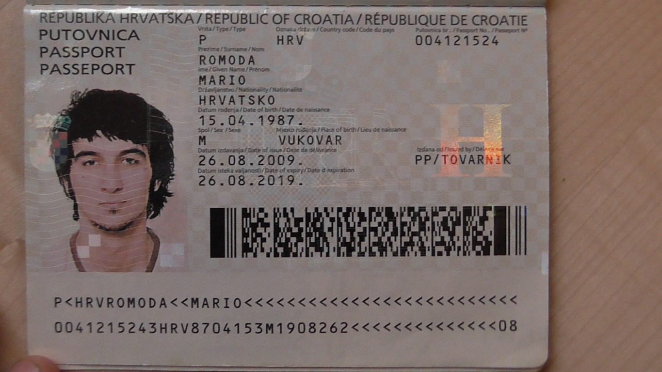

**Surname (s ) / First name (s )** : Romoda Mario

**Address (es )** : Sixth oranički branch 2.10090 , Susedgrad , Zagreb ( Croatia )

**Mobile Phone Number** : 0923230962

**Email**: mromoda7@gmail.com

**Nationality**: Croatian

**Date of birth**: 15/04/1987

**Gender**: Male

**Desired employment / Occupational activities :** related to art education , various workshops

**Work experience:**

Main activities and responsibilities : painting,activities related to art education , various workshops , photography, experimental short movies

Name and address of employer : Academy of Fine Arts

Ilica 85 , 10000 Zagreb ( Croatia )

**Education and training**

Dates: 1 September 06 to 14 February 12

Title of qualification awarded: **Master of painting**

Principal subjects / occupational skills: Skills acquired artistic education .

Name and type of organization providing education and training :

**Academy of Fine Arts ( HUMANITIES )**

**Ilica 85 , 10000 Zagreb ( Croatia )**

Level in national or international classification **: Master painting**

Personal skills and competence: knowledge of general culture , linking fact , a quick understanding , skill ..

Mario Romoda was born 15.04.1987 in Vukovar . He grew up on the island Njivice where he attended elementary school . School of Applied Arts , Textile and Design and writes and ends in Osijek . In Zagreb in 2006 he decide direction in painting at the Academy of Fine Arts . He graduated in the class of Zoltan Novak 2012. He had four solo and many group exhibitions . He lives and works in Zagreb

**Additional information. Prizes:**

1.First place in Osijek in 2004 .

Generational Award for the third year at the national level .

2.The first place at the national level to contest homes " Domijada 2004 "

3.First place at the national level to contest homes " Domijada 2005 "

4.Best student in the first year of painting at the Academy of Fine Arts .

5.Best student in the third year of painting at the Academy of Fine Arts .

6. First place in the " Biennial of Student Drawings " in Belgrade .

7.Best work at the Academy of Fine Arts Year 2011

8.Nominated for the best thesis at the Academy of Fine Arts , 2012 years