MARC STANDING

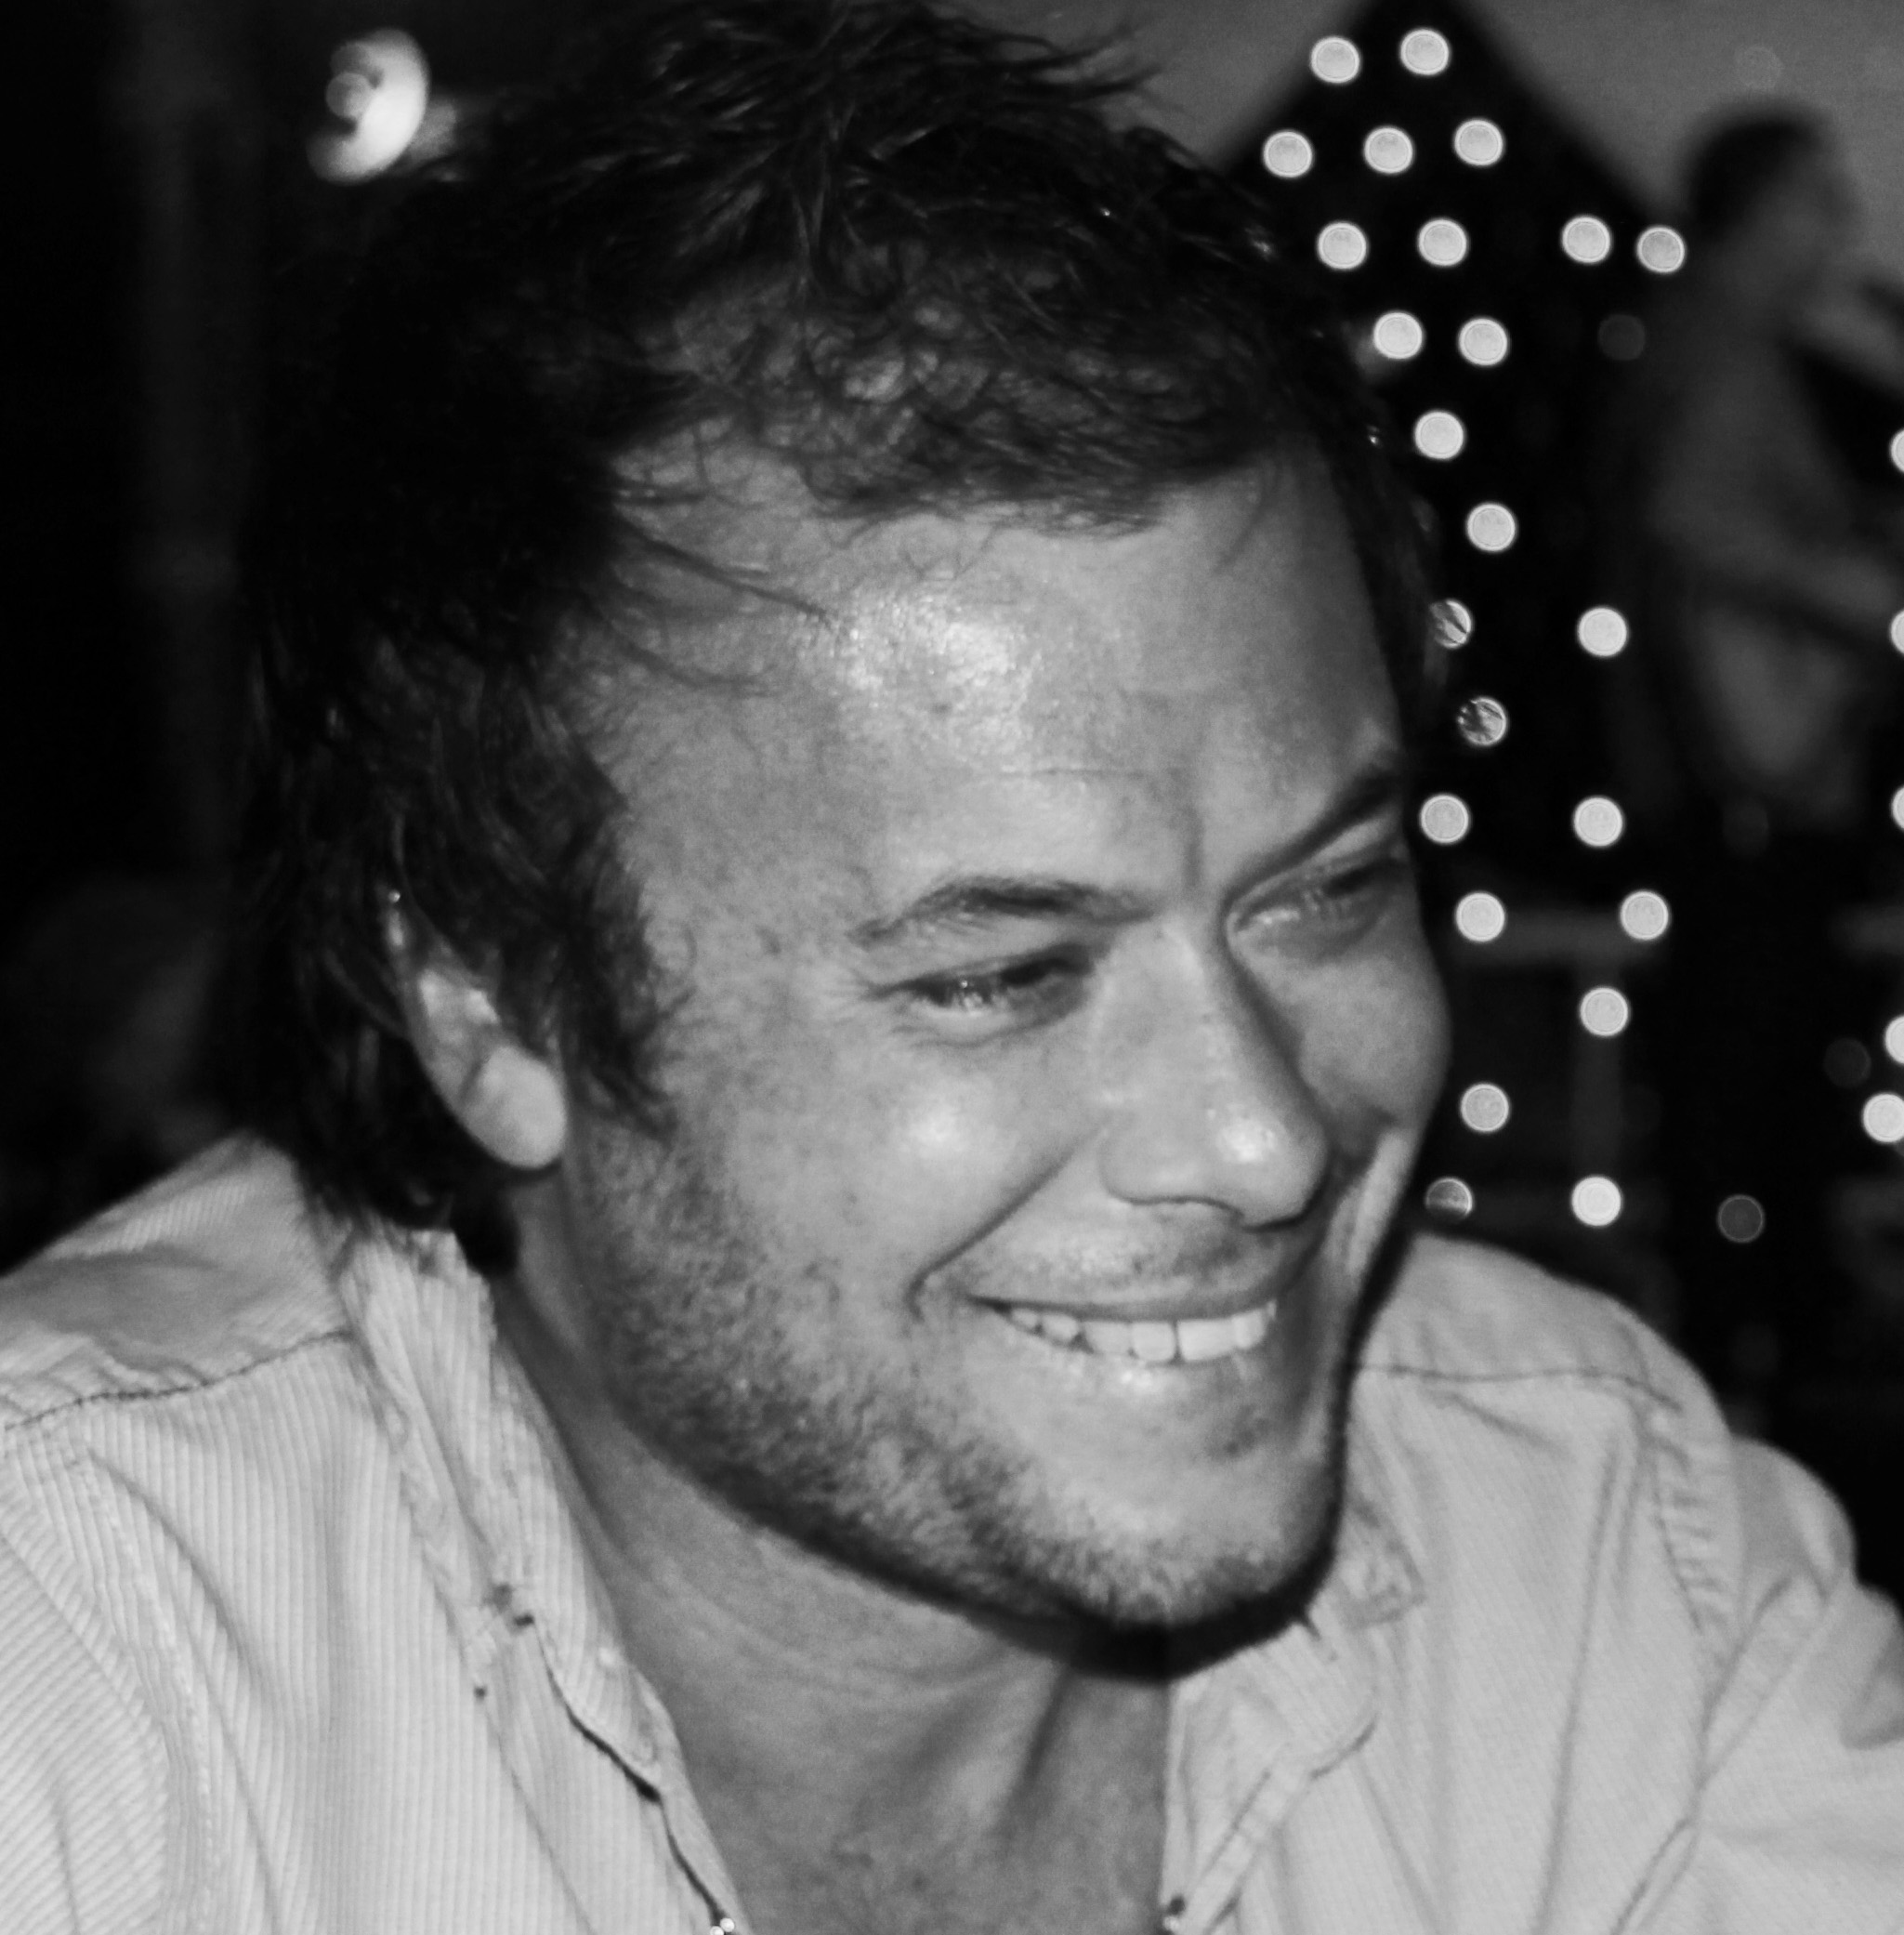

Born 1976, Harare, Zimbabwe.

Education, 1996-1999, Bachelor of Fine Arts Honors Degree, University of Cape Town, South Africa.

Represented by Anna Pappas Gallery, Melbourne. The Cat Street Gallery, Hong Kong. King Street Gallery, Sydney.

BIOGRAPHY

Born in Zimbabwe, based in Sydney and now more recently in Hong Kong, Standing's iconic and haunting paintings have developed along a complex path of progression. Driven by an innate compulsion to paint, Standing explores tension felt by a personal search for identity, embodied by complexities felt by a mass consciousness - one which has been left with toxic traces of colonialism.

For this is what packs such a punch in Standing's work - the other -worldly layering of textures and imagery which evoke a surreal clarity in the viewer. Standing's recent eerie yet peaceful paintings use a palette and compositional platform, mixed with sinister imagery, to explore the tensions felt between light and dark; comfort and discomfort; a sense of belonging and a sense of void.

His works have been shown extensively throughout Australia and have also been included in prominent Australian art prizes, as well as a commission work for The Groucho Club in London, a nominee for the Sovereign Asian Art Prize, and acquired by Artbank in Australia. His work has also been exhibited in New York, London, Holland, Hong Kong, South Africa and Zimbabwe.

*Zelie Walker, Gallery Director at Cat Street Gallery, Hong Kong.*

SOLO EXHIBITIONS

2015

*‘The Shadow Men’*, King Street Gallery, Sydney, Australia.

2014

*‘The Mystics’,* The Cat Street Gallery, Hong Kong.

2013

*‘The Phosphorescence’*, King Street Gallery, Sydney, Australia.

*‘Lost Wonders’*, Anna Pappas Gallery, Melbourne, Australia.

*‘The Duchess of Avon’*, Trink Tank Tank, Melbourne, Australia.

2011

*‘Waking Me Forever’,* Brenda May Gallery, Sydney, Australia.

2009

*‘Terra Australis Incognita’,* Brenda May Gallery, Sydney, Australia.

*‘The Unknown Land of the South’*, Dickerson Gallery, Melbourne, Australia.

2008

*‘Teraphim’*, Brenda May Gallery, Sydney, Australia.

*‘The Playground’,* South Coast Gallery, Wellington, New Zealand.

2007

*‘New Painting’*, Brenda May Gallery, Sydney, Australia.

2006

*‘Waking Dreams; An Australian Portrait’,* Noosa Regional Gallery, Noosa, Queensland, Australia.

2004

*‘The Human Wreckage’,* Gallery Wawana, Maastricht, Holland.

2003

*‘Metamorphia’,* Gallery Wawana, Maastricht, Holland.

2002

*‘A Post Apocalyptic Independence’*, Gallery Wawana, Maastricht, Holland*.*

2001

*‘Psychosis’*, Gallery Delta, Harare, Zimbabwe.

GROUP EXHIBITIONS

2015

*‘New York Now! 015’*, Factory Arts Project, New York.

*‘Clifford Chance Pop Up,’* Clifford Chance, in support of the LGBT community, Hong Kong.

2014

*‘Platform for Emerging Artists’,* Leyden Gallery, London, UK.

*‘Dreaming in Colour’,* Art Labor, Shanghai, China.

*‘Justice Center Human Rights Art Prize,’* Sundaram Gallery, Hong Kong.

*‘Waterhouse Natural Science Art Prize’*, Finalist, South Australian Museum, Adelaide, Australia.

*‘Signal 8 : Summer Show’,* Cat Street Gallery, Hong Kong.

*‘Art Athina’,* Anna Pappas Gallery, Athens, Greece.

*‘Op Smile Fundraiser Auction’,* The Space/Mandarin Oriental, Hong Kong.

*‘Redlands Konica Minolta Art Prize’*, Finalist, NAS, Sydney, Australia.

2013

*‘Signal 8 : Summer Show’,* Cat Street Gallery, Hong Kong.

*‘Art Athina’,* Anna Pappas Gallery, Athens, Greece.

‘*Wonder Works’*, The Space, Art HK 2013, Cat Street Gallery, Hong Kong.

*‘Sovereign Asian Art Prize Exhibition’,* Finalist,Rotunda Exchange Square, Hong Kong.Espace Louis Vuitton, Singapore.

*Affordable Art Fair,* Cat Street Gallery, Hong Kong.

*‘Project 13, Jamais Vu’*, Anna Pappas Gallery, Melbourne, Australia.

*‘Looking Forward’*, King Street Gallery, Sydney, Australia.

*‘Project30, The Sex Issue’,* online, [www.project30.com](http://www.project30.com).

*‘Clayton UTZ Art Award’*, Finalist, Brisbane, Australia.

2012

*‘Operation Smile’,* The Space, Hong Kong.

‘*Signal 8: STORM’*, Cat Street Gallery, Hong Kong.

*‘A Verdant Heart’,* King Street Gallery, Sydney, Australia.

*‘Five Bells’,* Damien Minton Gallery, Sydney, Australia.

*‘Work on Paper’,* Jeffrey Leder Gallery, New York, USA.

*‘International Painting NYC’*, Jeffrey Leder Gallery, New York, USA.

*‘The Sketch Book Project: The Limited Edition’*, Brooklyn Library, Brooklyn, New York, USA.

*‘Lightbombs Pop Up Exhibition’*, Art East Island, HK12, Hong Kong.

*‘Clayton UTZ Art Award’*, Finalist, Brisbane, Australia.

*‘John Fries Memorial Art Prize’,* Finalist*,* Gaffa Gallery, Sydney, Australia.

*‘Wilson Visual Arts Award*’, Finalist, Trinity College, Lismore, NSW, Australia.

*‘Lethbridge 10000 Art Award’,* Finalist, Lethbridge Gallery, Brisbane, Queensland, Australia.

*'Urban Creatures : Toyota Emerging Art Award',*Finalist, Toyota Emerging Art Exhibition*,* Port Melbourne, Australia.

*‘Year In Review’*, Top 100 Finalist, Artists Wanted, online.

2011

*‘Body Language’*, Brenda May Gallery, Sydney, Australia.

*‘LA Art Show’*, Skotia Gallery, Los Angeles Convention Center, Los Angeles, USA.

‘*Vista Wellington Art Fair’*, South Coast Gallery, Academy of Fine Arts, Wellington, New Zealand.

*‘Art Takes Miami’*, Top 100 finalist, Artists Wanted, online.

2010

*‘Snowballs and Disco’*, Amelia Johnson Contemporary, Hong Kong.

2009

*‘On Paper’*, Dickerson Gallery, Melbourne, Australia.

*‘City of Whyalla Art Prize’,* Finalist, Whyalla, South Australia.

*‘Banyule City Council Works on Paper Award’*, Finalist, Bayule City Council, Ivanhoe, Melbourne, Australia,

*‘Hazelhurst Art Award’*, Finalist, Hazelhurst Regional Gallery, Hazelhurst, NSW, Australia.

*‘Calleen Art Award’*, Finalist, Cowra Regional Gallery, Cowra, NSW, Australia,

*‘Off The Wall’*, Art Melbourne 09, Royal Exhibition Building, Melbourne, Australia.

2008

‘*Melbourne Art Fair’*, Brenda May Gallery, Royal Exhibition Building, Melbourne, Australia.

*‘Memento Mori’*, Brenda May Gallery, Sydney, Australia.

*‘Narrative’*, Brenda May Gallery, Sydney, Australia.

*‘Birthday Show’*, Brenda May Gallery, Sydney, Australia.

*‘Shelf Life’*, Delmar Gallery, Sydney, Australia.

*Touring Blake Prize for Religious Art.*

2007

*‘I’m as Mad as Hell’*, Brenda May Gallery, Sydney, Australia.

*‘Art Melbourne 07’*, Royal Exhibition Building, Melbourne, Australia.

*‘Fishers Ghost Art Award’*, Finalist, Campelltown Arts Center, Campelltown, NSW, Australia.

*‘Blake Prize for Religious Art’*, Finalist, National Art School, Sydney, Australia.

‘*Mosman Art Prize,’* Finalist ,Mosman Art Gallery, Sydney, Australia.

2006

*‘New Breed’*, Global Gallery, Sydney, Australia.

‘*Churchie Emerging Art Award’*, Finalist , Brisbane, Queensland, Australia.

2003

*‘Zimbabwe Now’*, The Royal Academy, The Hague, Holland.

*‘Artists for Zimbabwe’*, Gallery 27, Cork Street, London, UK.

2002

*‘Business As Usual’*, Harare International Arts Festival [HIFA], National Gallery, Harare, Zimbabwe.

2001

*‘Mobil Heritage Exhibition’*, National Gallery, Harare, Zimbabwe.

2000

*‘Ikons’*, Gallery Delta, Harare, Zimbabwe.

*‘Works on Paper’*, Gallery Delta, Harare, Zimbabwe.

AWARDS AND RESIDENCIES

2015

One & Only residency, Reethi Rah, Maldives.

2014

Justice Center Human Rights Choice Award.

Arquetopia, Day of the Dead residencey, Puebla, Mexico.

2013

*‘Clayton UTZ Art Prize’*, Highly Commended Award, Brisbane, Australia.

2006

‘*Regional Art Awards’*, Finalist , Pinnacles Gallery, Thuringowa. Raw Space Gallery, Brisbane, Queensland, Australia.

2005

*‘Regional Art Award’*, Viewer’s Choice Award’, Finalist , Regional Art Award, Queensland, Australia.

PUBLISHED/REPRODUCED

2015

The Sketchbook Project World Tour, Steven Peterman & Sara Elands Peterman, pg 189, Princeton Architectural Press.

In House, Swire magazine.

2013

Kee Magazine, ‘The Changeling’, March issue.

The Age, Entertainment, 'Your Weekend: in the galleries', Dan Rule, 16 March 2013.

The Age, Entertainment, 'Bodies cast in a state of sexual ambiguity', Robert Nelson, 13 March 2013.

South China Morning Post, 'Four locals in running for region's biggest art prize', 31 Thursday January , C3.

The Works, aired on TVB Pearl, Hong Kong, 5 March 2013.

CORNER Magazine interview, Kevin Junk, March 2013, thecornermagazine.com.

'Natural Wonder', Commentator Alan Pigot, YouTube, 29 January, 2013.

2012

Sydney Morning Herald, Spectrum, ‘Sparkle and shade’, pg 10, Steve Meacham.

Queens Ledger, ‘International Art Meets New York City’, 12 January.

2011

Prestige magazine. Fanfare, October 2011, pg 84

2010

Inside Out Magazine, pg 53

2009

T. Clement, ‘Metropicks’, SMH [Metro], 4 September, pg 14.

‘Profiles’, Art Almanac, September, pg 195.

2008

Human Rights Defender, vol 17 # 3, December, back cover.

‘Postcards’, Art News Magazine, K. Corner, pg 42.

‘The Planner’, SMH [Spectrum], 21 June, pg 6.

‘Open Gallery’, SMH [Spectrum], 14 June, pg 18.

Central Magazine, 28 June, pg 27.

‘Top Shelf’, SMH [Metro], 30 June, pg 2.

2007

‘Discovering Dank Street’, Sydney Star Observer, P. Simpson, 31 May, pg 15.

‘The Theory of Relativity’, Central Magazine, Culture, May 16, pg 19.

2006

‘Smart Art’, Sunshine Coast daily Revive Magazine, G. Arnold, April 29, pg 6-8.

2002

‘Onzerwereld Magazine’, A. van de Heide, April, pg 50-51.

Limburgs Dagblad Newspaper, 9 March, pg 37.

2001

‘Altered States’, Gallery Delta Magazine, F. Marks.

COLLECTIONS

The Groucho Club, London, UK.

Artbank, Australia.

Private collections, Hong Kong, Australia, South Africa, New York, London, Holland.