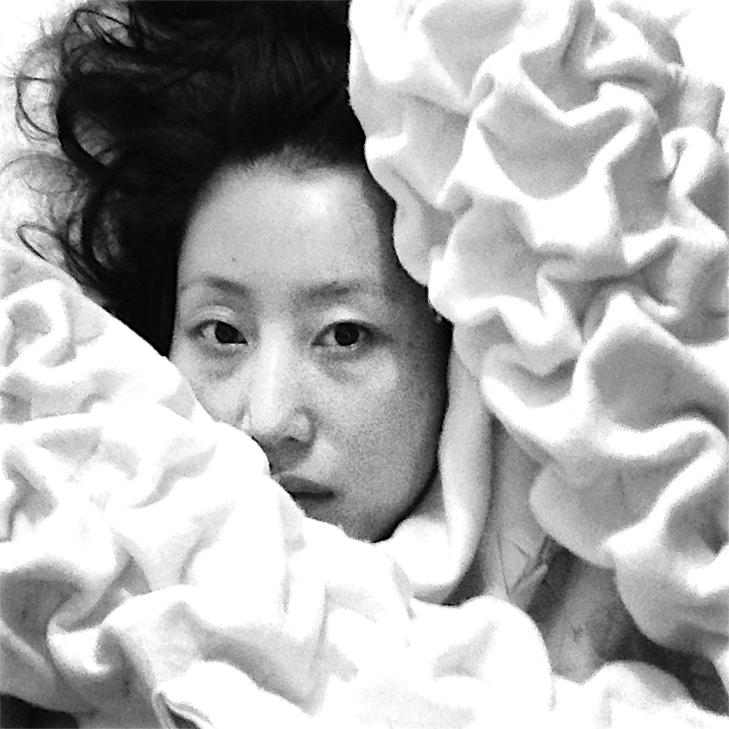
CURRICULUM VITAE
EUN JEONG JEON eunjeongjeon@hotmail.com/jeong90@hotmail.com http://eunjeongjeon.wix.com/infor

Eunjeong Jeon is an artist-designer-researcher with extensive experience in (interaction) design and research-through design. Her research and creative practice is interdisciplinary and she has strong interests in designing for the aesthetics of interaction, with special focus on understanding how the emotion, sensory and movement dimensions of the lived body contribute to an object creation in relation to human health and well-being. Since completing her doctorate, Designing Enriched Aesthetic Interaction for Garment Comfort, in 2013 her research has expanded to include how the integration of new technologies with textiles offers innovative design possibilities. Related creative artworks are based on the design of emotional objects and designing an approach to interaction that is integrated with multi-sensory-movement qualities through investigating complex phenomenological activities and human behavioral processes. Design methods and tools based on user-centred and participatory design methods are central to her research projects. She is a member of Designing Quality in Interaction (DQI) group, at the Department of Industrial Design, the Netherlands since 2012. She is also a member of Crash, Collaborative Research in Art, Science and Humanity, Curtin University, WA since 2009.

She studied at the Denmark International Study (DIS) Program (1996) in Furniture Design and graduated at Hong-ik University, School of Fine Art (BA), Seoul, South Korea in 1997. After study of BA she worked in the field of art furniture as a designer. Once she moved in Australia in 2001, she studied at the School of Art and Design, Curtin University, Western Australia where she graduated with a Diploma in Design and Visual Art and also obtained Master of Design in 2005. Her MA project applied emotional aesthetics to chair design through a cross-cultural examination of sitting behaviour and cognitive images. This was followed by participation in Thingness of Thing and Thing from the Void in Visual Art project 2006, which involved research into the body’s interaction with spatial tactility. She focused on the extension of her professional experience through participation in the FORM “Designing Futures” industry cluster project, Perth, Western Australia in 2007. She received her Doctor of Philosophy degree in Design at Curtin University in 2013.

Eunjeong’s doctoral research (2013) realised a deeper and broader understanding of comfort for garment design gained from sensori-motor research into wearers’ emotional needs and their subjective experience in daily activities. This research substantially contributes to expanding the discourse on comfort by investigating in influence of kinetic interaction, emotion, and aesthetics to enhance comfort, through a user participatory design approach. Her research shows how the design process can incorporate a user-centred approach in applying qualitative and quantitative research techniques, such as motion capture and Laban’s movement analysis. The strength of her research lies in the practical application of the Enriched Aesthetic Interaction framework to a series of innovative textiles design called Trans-For-M-otion that that led to the development of a set of design principles based around serendipity, kinaesthetic, evoking mood and enjoyment.

Her research expands the integration of textiles with technology for human health and wellbeing. She was involved in the Smart Textiles Services (STS) project (2012-2014) that is part of Creative Industry Scientific Programme at Department of Industrial Design, Eindhoven University of Technology in the Netherland. In this STS project, she investigated how properties of wool and felted wool technique interlaced with conductive yarn would enhance tactile and sensorial effect. This design was aimed to inform a multi-disciplinary audience about the opportunities of integrating textile and vibration for self-healthcare services at home or even in everyday activities. This work was a collaborative design project with TextielMuseum TextielLab and Metatronics, the Netherlands for their contributions in realizing smart textiles.

She has exhibited in the Netherlands, UK, Spain, South Korea, China, Belgium, New Zealand and Australia presenting in the examples of emotion crafted in textiles, technology integrated textiles (smart textiles). Eunjeong’s creative work has been included in recent publications on textile innovation and sustainable design and examples included in the recent Fashion Now exhibition at the Museum Boijmans van Beuningen Rotterdam, the Netherlands, (11 Oct 2014 - 18 Jan 2015). She also has engaged with industry and has presented the research aspect of her creative work at international conferences in London, Newcastle, Sheffield, Belgium, Catalonia, Eindhoven, Helsinki, Borås and Seoul.

Academic Qualifications
2007~2013  2005~2006  2004~2005  1992~1997 1996 | Doctor of Philosophy in Design, Curtin University, Perth, WA.  Post Graduate Diploma in Visual Arts, Curtin University, Perth, WA.  Master of Design, Curtin University, Perth, WA.  Bachelor of Fine Arts, Hong-ik University, South Korea.  Certificate of Furniture design, DIS (Denmark’s International Study Program), Copenhagen, Denmark.

Professional Experience
Feb 2013 ~ Feb 2014  Oct 2012~ Jan 2013 | Post-Doc researcher in Designing Quality in Interaction (DQI) at the Department of Industrial Design, Eindhoven University of Technology.  Guest researcher, Artist in residence in Designing Quality in Interaction (DQI) at the Department of Industrial Design, Eindhoven University of Technology.

Previous Project Included
2013  2007  2006 | Vibe-ing: Smart Textile Services (STS) project (2013). This project was part of Creative Industry Scientific Programme (http://crispplatform.nl/projects/smart-textile-services) at Department of Industrial Design, Eindhoven University of Technology in the Netherland. Led by project leader, Dr Oscar Tomico (Department of Industrial Design, Eindhoven University of Technology, the Netherlands).  PhD research project (2013): Designing enriched aesthetic interaction for garment comfort. ARC Linkage project (2007-2010) “Innovative Solutions for Wool Garment Comfort though Design” (Project ID: LP0775433), in conjunction with the Wooldesk at DAFWA (Department of Agriculture and Food, Western Australia). Led by Professor Suzette Worden (Curtin University of Technology) and Anne Farren (Curtin University of Technology), Dr John Stanton (Department of Agriculture and Food, Western Australia (DAFWA).  Designing Future Cluster Development project (2007). Professional design industry experience through participation in the FORM. Led by Australian furniture designer, John Goulder.  Visual Arts project (2006). Thing from Thingness Thing from the voice. Research into the body’s interaction with spatial tactility. Curtin University of Technology.

Book Chapter
2015 | Jeon, E. (2015). Fashion Design for Living. In Alison Gwilt (Eds), Form empowered by touch, movement, and emotion, (pp.134-150). London, UK:Rouledge.

Selected Peer Reviewed Journal and Conference Papers
2013  2012  2011  2010  2009 | Jeon, E. (2013). ‘Emotional object creation’: Experiencing through unknowing, knowing through experiencing. In Design Principles and Practices: The International Journal of Design in Society, 7(2), 1-17. University of Illinois Research Park, USA: Common Ground Publisher.  Jeon, E. (2013). ‘Touch me, Feel me, Play with me.’ In Praxis and Poetics: Research Through Design Conference Proceedings 2013 held in Newcastle upon Tyne & Gateshead, 3-25 Sep 2013. The Baltic Centre, Contemporary Art, UK.  ten Bhömer, M., Jeon, E., & Kussk, K. (2013). Vibe-ing: Designing a smart textile care tool for the treatment of osteoporosis. In L. Feijs, S.Fraser, S. Kyffin & D. Stefen (Eds.), In Proceedings of 8th International Conference on Design and semantics of form and movement DeSForM 2013 held in China, 22-25 Sep, 2013 (pp. 192-195). Wuxi.  Jeon, E. (2012). ‘Enriched aesthetic interaction’ through sense of dynamic emotional bodily expression with garment: quantitative analysis with Motion Capture (MC) data. In J. Brassett, J. McDonnell & M. Malpass (Eds.), Proceedings of 8th International Design and Emotion Conference 2012 held in London 11-14 2012, Central Saint Martins College of Art & Design.  Jeon, E. (2011). ‘Enriched aesthetic interaction’ through sense from haptic visuality. In Design at the Edges: Proceedings of International Design Alliance (IDA) Congress Education Conference 2011 held in Taipei, Taiwan 24-26 Oct 2011 (pp.28-35). Taipei International Convention Centre (TICC). Retrieved from http://www.icsid.org/uploads/media/idacongress/Eunjeong_Jeon.pdf  Jeon, E. (2011). Fremantle on the Edge vol 4, Intertidal. In Nancy Spanbroek & Anne Farren (Eds), Body shadow water, body shadow sand, (pp. 24-27). Perth: Paper and Pencil.  Jeon, E. (2010). ‘Aesthetic experience and comfort’: Garment design integrated with movement qualities, dynamic bodily expression, and emotion. In P. Lévy., & C. Bouchard., & T. Yamanaka., & A. Aoussat (Eds.), Proceedings of Kansei Engineering and Emotion Research (KEER) International Conference 2010 held in Paris, France 2-4 March 2010 (pp.1917-1929). Arts et Metiers ParisTech.  Jeon, E. (2009). ‘Object playing with movement’: A source of comfort and enjoyment. In K. Lee (Eds.), Rigor and Relevance in Design: Proceedings of an International Association of Societies of Design Research (ISASDR) Conference 2009 held in Seoul, Korea, 18-22 Oct 2009 (pp. 18-22). Seoul, Korea: Korean Society of Design Science.  Jeon, E., & Worden, S. (2009). ‘Aesthetic experience and comfort’: The relationship between semantic form and body movement for the design of wool clothing. In K. Lee (Eds.), Rigor and Relevance in Design: Proceedings of an International Association of Societies of Design Research (IASDR) Conference 2009 held in Seoul, Korea, 18-22 Oct 2009. Seoul, Korea: Korean Society of Design Science.

Selected Studio Workshop & Activities
2014  2013  2012  2011  2010  2009 | Invited to show film: Affective Touch, at Design Films: ArcInTex Symposium  Embodied Interaction Research Techniques, at the Department of Industrial Design, Eindhoven University of Technology, the Netherlands, 15-16 Oct 2014.  Retrieved from  http://www.dance-tech.net/profiles/blogs/call-for-content-design-filmsembodied-  interaction-research  Invited talk for Fashion Futures Symposium, School of Art and Design, Curtin University of Technology, Perth, WA, 25 Oct 2014.  Retrieved from https://www.facebook.com/FashionFuturesSymposium/  Invited coach for Close to the Body research studio workshop, Master in  Advanced Interaction at Institute for Advanced Architecture of Catalonia  (IAAC). Held at Pujades 102, 08005 Barcelona, Spain, 11-15 Feb 2013.  Retrieved from http://www.iaacblog.com/mai2012-2013-closetothebody/  Invited lecturer for Walking as art of movement workshop at the Department of  Industrial Design, Eindhoven University of Technology, Eindhoven, the  Netherlands, 5 Nov 2013.  Invited coach for Crafting Wearables workshop where students of the Master  Industrial Design at TU/e and Master Fashion Design at ArtEZ, the Netherlands  were participated, 18-22 Nov 2013.  Invited coach for Balanced Bodies, Moving Mind, Wearable Senses, the Department of Industrial Design, Eindhoven University of Technology, Eindhoven, the Netherlands. Retrieved from  http://w3.id.tue.nl/fileadmin/id/Education_Documentation/Project_descriptions/  1314-S2-_Wearable_Senses.pdf  Invited talk For Seminar: Form Empowered by Touch, Movement, and Emotion, The Swedish School of Textiles, University of Borås, Sweden, 09 Dec 2013.  https://www.hb.se/en/The-Swedish-School-of-Textiles/About-the-Swedish-School-of-Textiles/News-and-events/Events/designseminar/Previous-seminars1/  Invited talk for Design debates: Craftism: Saving the world knit by knit, Designhuis, Eindhoven, the Netherlands, 20 Nov 2012. Retrieved from: https://www.designacademy.nl/News/tabid/2055/articleType/ArticleView/articleId/1834/Craftism-Saving-the-world-knit-by-knit.aspx  Invited talk to School of Humanities, Loyal College Art of School, London, UK, 6 Nov 2012.  Invited talk to the Art and Design Research Center, Sheffield Hallam University, Sheffield, UK, 29 Dec 2012.  Invited talk to the Department of Architecture, Curtin University of Technology, Perth, WA.  Invited talk to London College of Fashion, UK.  Invited talk to the Department of Industrial Design, Eindhoven, the Netherlands.  Invited talk to the Department of Woodworking and Furniture Design, Hong-ik University, Seoul, South Korea.  Crash, Collaborative Research in Art, Science and Humanity, Curtin University.  Retrieved from http://crash.curtin.edu.au/research/groups/body/eunjeongjeon.cfm

Selected Exhibitions
2014~  2015  2014  2013  2010  2009  2005  1998  1997  1997 | Fashion is Now exhibition Exhibit for Disguise Garment. Held at Museum Boijmans van Beuningen Rotterdam, the Netherlands, 11 Oct 2014-18 Jan 2015. Retrieved from http://futureoffashion.nl/designers  Smart Flexibility: Advanced Materials and Technologies exhibition Exhibit for Vibe-ing. Held at Disseny Hub Barcelona, Spain, 25 June-20 Dec 2014.  Retrieved from http://exhibitions.materfad.com/wp-content/uploads/2014/01/EN_19_12_2013_Smart-Flexibility-file.pdf  Shapeshifting exhibition Exhibit for Vibe-ing as Smart Textiles designed by Jeon, E, Kussk, K., & ten Bhömer. Held at Window Space Gallery AUT University, WE Building, St Paul Street, New Zealand, 14-30 April.  Praxis and Poetics: Research Through Design Conference exhibition Exhibit for Touch me, Feel me, Play with me. Held at The Baltic Centre, Contemporary Art, Newcastle upon Tyne & Gateshead, UK, 3-5 Sept 2013.  ArchInTex Network exhibition Exhibit for Vibe-ing designed by Jeon, E, Kussk,  K., & ten Bhömer. Held at Tio3, Ronse, Belgium, 14-18 Oct 2013.  Dutch Design Week exhibition Exhibit for Vibe-ing as health care tool designed  by Jeon, E, Kussk, K., & ten Bhömer. Held at Designhuis, Eindhoven, the  Netherlands, 19-27 Oct 2013.  Beijing Design Week exhibition Exhibit for Vibe-ing as health care to designed by Jeon, E, Kussk, K., & ten Bhömer. Held at The Dutch Pavilion, Beijing, China, 26 Sep-3 Oct 2013.  Design4Health exhibition Exhibit for Vibe-ing as health care tool designed by Jeon, E, Kussk, K., & ten Bhömer. Held at Sheffield Hallam University, Sheffield, UK, 3 -5 July 2013.  Smart Textiles Salon exhibition Exhibit for Vibe-ing as health care tool designed by Jeon, E, Kussk, K., & ten Bhömer. Held at Museum of Industrial Archaeology and Textiles (MIAT), Ghent, Belgium, 6 June 2013.  Beyond Garment exhibition Exhibit for Trans-For-M-otion. Held at Western Australia Museum, Fremantle, WA, 3 Sep-30 Nov 2010.  Extreme Edges exhibition Exhibit for Form and Formlessness. Held in Fremantle, WA, 8 May-5 June 2009. Retrieved from  https://humanities.curtin.edu.au/schools/BE/architecture_interiorarchitecture/pdf/  fremantle_summary_event.pdf  Eleven exhibition Exhibit for The Spirituality of No. 11. Held at John Curtin  Gallery, Curtin University, Bentley, WA, 24 Oct -11 Nov 2005.  Retrieved from http://provocation.curtin.edu.au/downloads/11invite.pdf  http://johncurtingallery.curtin.edu.au/exhibitions/archive/2005.cfm#eleven  MOST exhibition Exhibit for Wedding & Objects. Held at COEX (Convention  and Exhibition: World trade Centre), Seoul, South Korea, 24 -29 March  1998.  MOST exhibition Exhibit for Wedding & Objects. Held at COEX (Convention  and Exhibition: World trade Centre), Seoul, South Korea.  Hong-ik University Graduation Degree Show Exhibit for Oneness. Held at  COEX (Convention and Exhibition: World trade Centre), Seoul, South Korea, 15  -20 Nov 1997.

Books and Thesis A selection of work has appeared as illustrations in international books.
2014  2013  2012  2011  2005 | Trans-For-M-otion appeared in The Future of Fashion is Now (2014, pp. 46-47) edited by José Teunissen, Han Nefkens, Jos Arts, Hanka van der Voet and published by Museum Boijmans Van Beuningen, Rotterdam.  Trans-For-M-otion appeared in Textile Visionaries: Innovation and Sustainability in Textile Design (2013, pp. 222-231) edited by Bradley Quinn and published by Laurence King Publishers, London.  Jeon, E. (2013). Designing enriched aesthetic interaction for garment comfort. (Unpublished doctoral thesis). Perth, WA: Curtin University.  Trans-For-M-otion appeared in Fashion Futures (2012, pp. 42-43) edited by Bradley Quinn and published by Merrell, London.  Trans-For-M-otion appeared in Advanced Textile for Health and Well-being edited (2011) by Marie O’Mahony and published by Thames & Hudson.  Jeon, E. (2005). Application of the concept of emotional aesthetics in designing chair-sitting behaviours and cognitive images. (Unpublished Masters dissertation). Perth, WA: Curtin University.

Awards and Grants
2011  2007 | Curtin University, Faculty of Humanities, Humanities Research Award 2011,  Greg Crombie Postgraduate Award ($2,000)  Australian Postgraduate Award Industry (APAI) from Australian Research  Council (ARC) project “Innovative Solutions for Wool Garment Comfort  through Design” (Project ID: LP0775433) in conjunction with the Wooldesk at  DAFWA (Department of Agriculture and Food, Western Australia).  VIVID Concept-Prototype Melbourne Exhibition Centre.

