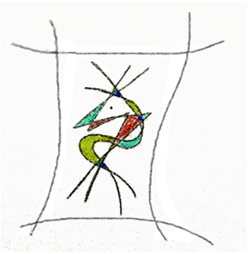

Curriculum
Magdalena Hohlweg

Höperfeld 10a, 21033 Hamburg
lena@hohlweg.de www.hohlweg.de

- 2015 Audience Award Kunstmesse.25 Frauenmuseum Bonn
- 2014 Audience Award International Art Exhibition „FormArt“, Glinde at Hamburg, 2. Winner
- 2013 Audience Award International Art Exhibition “FormArt”, Glinde at Hamburg, 3. Winner
- 2012 Audience Award Art Exhibition “Aurakure”, Hamburg

- since 2008 living and working in Hamburg, Germany
- since 2000 developing the first Miniature Collages
- 2000 – 2007 line of a Computerstore
- 1996 Exhibition Galerie Maria Kohl, DarmstadtGgermany
- 1995 Exhibition VHS Dorsten
- 1995 Participation in workshop „Anatomic sculpture“
Universität Duisburg with sculptor Holger Schmidt
- 1993-1997 own ceramic art workshop, focus on sculptures in construction technology
- 1962* Germany

