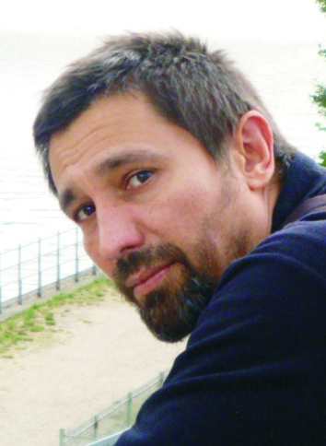 **Artist’s Curriculum**

**Daniel Mirchev** - DUNA is a Bulgarian sculptor with reputable art portfolio. He graduated the Art School of Plastic Arts "Dimitar Dobrovich" in Sliven city, Bulgaria.

He works mainly in the field of sculpture in wood and wood-carving. His artistic biography begins with participation in the National Exhibition of Fine Arts in his hometown of Yambol in 1989 and at the Salon of applied art in the city of Sliven. He has five solo exhibitions with sculpture in wood. His sculptures and other plastic art works are presented in a number of Sofia and Plovdiv galleries as well as purchased to France, Spain, Italy, Germany and Canada. He also has been designing and manufacturing unique and custom furniture.

His professional biography includes creative projects in the field of graphic design and décor creation. As manager and creative director of "Red Dot" – an agency for creative projects, design and decor, Daniel successfully implemented numbers of creative projects for private companies and European programs. For years he has being involved in designing and constructing sets for feature films, television studios and advertisings.

**SOLO EXHIBITIONS: 5**

**GROUP EXHIBITIONS: 8**